Installing USB Switcher App for Geo7X Series, Juno 3 Series, GeoExplorer 6000, Geo2008/3000 & TSC3 Windows Mobile Devices
Alaska Regional Office - GIS Team Cheat Sheet
Last Modified: June 9, 2020

Purpose
This document is intended to provide step-by-step instructions for installing USB SWITCHER APP on applicable Trimble receivers. Once a compatible Trimble has been properly switched using this App, the device can continue to use the data transfer utility in either Pathfinder Office or Positions for expedient file management.

Before You Begin
Heads Up #1
This Support Document currently is on the GNSS POS NAV Sharepoint site under HOW Tos!.

The USB Switcher app enables Data Transfer without Windows Mobile Device Center (WMDC). As of February 2020, WMDC is being deprecated in NPS due to security reasons.

Trimble® has released the USB Switcher app to overcome some of the issues with Windows Mobile® Device Center running on PCs powered by the Windows® 10 operating system. The USB Switcher app changes how a Trimble Windows Embedded Handheld device connects to a PC powered by the Windows operating system. Instead of using Windows Mobile Device Center to access the internal storage on the device, with the app you can instead access the SD card directly in a device and have that appear as a lettered drive in Windows on a PC. You can then set up Data Transfer to send and receive data from the Trimble TerraSync software to the Trimble GPS Pathfinder® Office or Trimble Positions software from this lettered drive.
When to use the USB Switcher app? The USB Switcher app works best for Trimble Mapping & GIS handheld users who already have the TerraSync software installed and set up on their device and only need to get data to and from the device. The solution does not work for users who need to install TerraSync software on their device. Installing TerraSync can only be done with WMDC.
Which Trimble devices are supported? This app works on Trimble GeoExplorer® 6000, Geo 7X handhelds, Trimble Juno® 3x (3B, 3C, 3D and 3E devices) and the TSC3 survey controller. It does not work on devices such as the Trimble GeoExplorer 2008 and 3000 series, as they do not support Mass Storage. It does not work on Trimble Juno 5 / T41 handhelds, Trimble Nomad® handhelds as they do not have the USB Mass Storage driver installed. Those devices will require copying files onto SD cards and manual transfer to a computer. On 2008/3000, and other older controllers like the Nomad, you can still transfer files via SD card but will have to physically remove card from Trimble. See Appendix A.
How does it work? The USB Switcher app runs on a Windows Embedded Handheld device and allows you to switch your device between using Windows Mobile Device Center (USB Mode: ActiveSync), and using USB Mass Storage. The USB Mass Storage option exposes the SD card in the device as a lettered drive in Windows. It DOES NOT expose the internal storage of the device; writing to the internal storage can only be done via the Windows Embedded Handheld operating system which requires the use of Windows Mobile Device Center. If there is no SD card in the device then nothing will appear in Windows. Once the Trimble is switched to using Mass Storage, then you do not have to re-install the app.

All receivers in this document were tested in Feb/March 2020 on Windows 10 NPS computers at 1709, 1803 and 1809 versions. Kingston microSDHC/SDCard adapters were used in these tests.
What you cannot do with the USB Switcher App? You will not be able to re-install Terrasync software on a device without WMDC. You can circumvent this issue by taking the receiver to a nearby Trimble dealer, or installing TerraSync from a home computer that has WMDC installed. Coordinate System files and Configuration files (*.stud/*.tcf) will also require manual file transfer on the Trimble using File Explorer. See this section.

Recommended SD cards Use this chart to see compatible SD card support depending on device. SDHC memory cards cannot be used in devices that support only SD cards. Limit to 32GIG or lower for 2008/3000 series devices. The Juno series require a micro SD card which fits under the battery. Our tests reveal any SD adapter/micro SD card combo will work. Recommend an extra card or two and pack an extra one in the GPS case in case someone forgets the card at work. Amazon prices here.
Special Note about devices that cannot use the App – See Appendix A.
SD Card readers. Because you will need to extract the SD card out of the Geoexplorer 2008/3000 series, we also recommend a modern card reader. Many new laptops do not come with a SD card slot. Here are 6 recommendations.

Installing USB Switcher App on Geo7X, Juno and TSC3 devices
Install Instructions for Geo7x, Juno 3X and TSC3 devices. SEE THESE STEPS FOR GEO6000 DEVICES
- Download the USB Switcher zip file from http://trl.trimble.com/dscgi/ds.py/Get/File-871020/UsbSwitcher.zip
- Extract the 3 files to a folder on a PC. This will create a USBSwitcher folder containing 3 files.
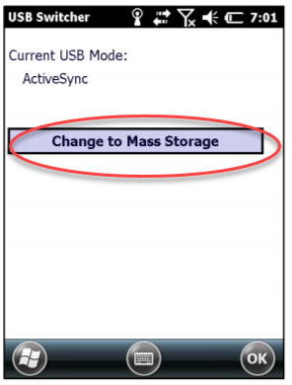
- Copy / Paste the entire FOLDER to an SD Card.
- Insert SD card into the device.
- Launch File explorer on the Trimble from the main screen.
- Select the Menu button (bottom right) and enable Show All Files.
- Using the stylus, select Storage Card from the pulldown bar upper left in File Explorer.
- Tap and HOLD the USB Switcher folder. Select Copy
- Select My Device from the pulldown bar upper left in File Explorer.
- Using the stylus, scroll to bottom of My Device and tap and hold in the open white space.
- Select Paste. You should now have a USBSwitcher folder in My Device.
- If you have connected the device to the host computer via a USB cable, disconnect the USB cable. Some computers still allow WMDC, and the Trimble won’t “let go” of USB mode using ActiveSync. Disconnect the USB cable from the Trimble then proceed to next step.
- Enable Advanced Network Functionality. On the Trimble select windows / Settings / Connections / USB to PC and check the box to enable. Press OK and close.
- With the SD card inserted in the Trimble, Run UsbSwitcher by single-tapping the USBSwitcher app inside the My Device/USBSwitcher folder. If the Current USB mode says ActiveSync/WMDC or RSNID, press the button to Change to Mass Storage. The Trimble will reboot.
- Repeat step 14 to confirm the app has switched to Mass Storage by browsing to the USBSwitcher file and single-tapping. The app should now state Current Mode: Mass Storage. If this is the case tap OK to cancel. You are now installed. If it remains stuck on RNDIS (Active Sync) or Active Sync/WMDC, then check again that the Advanced Network Functionality check box is switched on the Trimble. Do this by tapping the Windows icon/ Settings / Connections / USB to PC.
- Repeat Step 14 tapping the UsbSwitcher app. You may have to repeat this step twice.
- Once in Mass Storage mode (Current USB Mode: Mas Storage) you are done.
- Connect the Trimble to the computer using the USB cable and the device will connect as a drive letter to any Windows 10 computer. Our tests have shown this is persistent across any Windows computer as long as you have an SD card inserted.

Install Instructions for GeoExplorer 6000 handheld devices
The GeoExplorer® 6000 requires a driver to be installed on the handheld device before the installation of the USB Switcher App.
- Download the USB Mass Storage driver from http://trl.trimble.com/dscgi/ds.py/Get/File-936346/USB_MS.zip
- Extract the 1 file to a folder on a PC
- Copy the USB_MS.cab file onto the SD card
- Download the USB Switcher zip file from http://trl.trimble.com/dscgi/ds.py/Get/File-871020/UsbSwitcher.zip
- Extract the 3 files to a folder on a PC. This will create a USBSwitcher folder containing 3 files.
- Copy / Paste the entire FOLDER to an SD Card.
- Insert SD card into the device.
- Launch File explorer on the Trimble from the main screen.
- Select the Menu button (bottom right) and enable Show All Files.
- Using the stylus, select Storage Card from the pulldown bar upper left in File Explorer.
- Tap and HOLD the the USB_MS.cab file. Select Copy
- Select My Device from the pulldown bar upper left in File Explorer.
- Using the stylus, scroll to bottom of My Device and tap and hold in the open white space.
- Select Paste. You should now have a USB_MS.cab file in My Device.
- Tap USB_MS. Choose Device as the location to install “Trimble Navigation USB Mass Storage”
- Press OK to restart.
- After device restarts, navigate back to the Storage Card using File Explorer and tap and HOLD the USB Switcher folder. Select Copy
- Select My Device from the pulldown bar upper left in File Explorer.
- Using the stylus, scroll to bottom of My Device and tap and hold in the open white space.
- Select Paste. You should now have a USBSwitcher folder in My Device.
- If you have connected the device to the host computer via a USB cable, disconnect the USB cable. Some computers still allow WMDC, and the Trimble won’t “let go” of USB mode using ActiveSync. Disconnect the USB cable from the Trimble then proceed to next step.
- Enable Advanced Network Functionality. On the Trimble select windows / Settings / Connections / USB to PC and check the box to enable. Press OK and close.
- With the SD inserted in the Trimble, Run UsbSwitcher by single-tapping the USBSwitcher app inside the My Device/USBSwitcher directory. If the Current USB mode says ActiveSync/WMDC
or RSNID, press the button to Change to Mass Storage. The Trimble will reboot.
- Repeat step 23 to confirm the app has switched to Mass Storage by browsing again in File Explorer to the USB Switcher app. The app should now state Current Mode: Mass Storage If this is the case tap OK to cancel. If it remains stuck on RNDIS (Active Sync) or Active Sync/WMDC, then check again that the Advanced Network Functionality check box is switched on the Trimble. Do this by tapping the Windows icon/ Settings / Connections / USB to PC.
- Repeat Step 23 launching the UsbSwitcher app. You may have to repeat this step twice.
- Once in Mass Storage mode (Current USB Mode: Mas Storage) you are done.
Connect the Trimble to the computer using the USB cable and the device will connect as a drive letter to any Windows 10 computer. This will persist but you must have an SD card inserted.
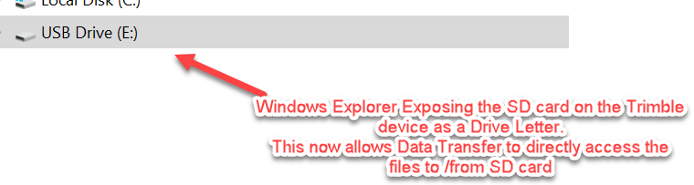

NOTE: If the USB Switcher app continues to return to Activesync Mode after a couple attempts to switch to Mass Storage, check the following:
- You may still have the USB cable attached to the computer. Disconnect cable and run app again.
- Ensure the Advanced Network Functionality check box on the Trimble is checked. Go to Windows icon/ Settings / Connections / USB to PC. This must be switched on (checked).
- Are all 3 files required for the switcher app placed together on the root of the Trimble device? This was done if you copied the entire folder containing all 3 files (Steps 19 – 23).
- Removing the SD card and reinserting is another way to wake up the device so the SD card
- Is the device updated to the most current OS/FW? See trimble.com/support and A-Z list.
- If there continues to be an issue, the device may need to have a HARDWARE RESET which will return the Trimble to default settings. This is a good thing to do especially for very old, hard working Trimbles. Like having a 10 year old PC that never was formatted!!! Backup the Trimble before doing a hard reset. You will need to re-install Terrasync which must communicate to the Windows PC with WMDC, so be sure to have a plan in place. See this guide.

Configuring TerraSync to read and write to the SD Card

You must next configure the TerraSync field software to read and write data to the SD card rather than the Default internal storage. You may have never used this storage location before if you always used WMDC, so you need to alter 4 of TerraSync’s Sections (Data/New, Data/Manager, Map/Background and Navigation/Waypoints) This must be repeated for all the Trimble devices in your fleet once you have run the Switcher App above.

- Disconnect the USB cable from the Trimble for this next step.
- Launch Terrasync on the device.

NOTE: If you leave the USB cable connected to a Trimble while altering the Storage locations, you will not be able to “see “ Storage Card. Disconnect USB cable when altering the location. Once you switch TerraSync over to use the Storage Card, you don’t have to worry about connecting, disconnecting the cable.

Here are the screenshots of where you need to alter Terrasync Locations for reading and writing data.

Data / New Data / Manager Map / Layers /Background Files
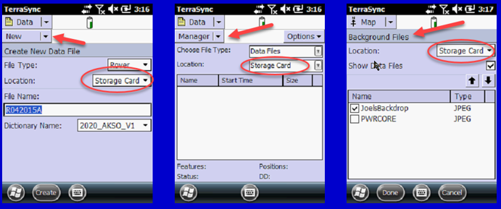

Navigation / Waypoints
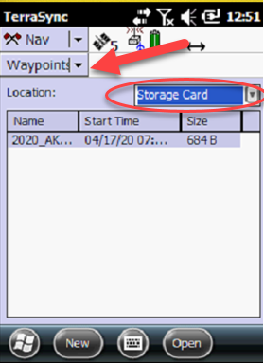
Don’t forget Map and Navigation sections also must be directed to pull JPGS and WPT files respectively for use on the handheld.

To Load Background maps, on the Map Section, accessing locations is done by selecting Map Section \ Layers, and select Background Files. Alter Location from Default to Storage Card.

To access Waypoint (WPT) files created in either PFO or Positions, Set the Waypoint Subsection in the Navigation section to look to the Storage card for location.

Congratulations. Your GPS is now set forever to bypass ActiveSync as a file transfer software since the USB switcher app controls the connection to the PC and TerraSync knows where to look for files.

If you forget to change the file location to Storage Card during a GPS Job copy the files from the SD Card Use the Data Section / File Manager subsection selecting Options / Copy To.

Configuring Data Transfer to transfer files directly to/from SD

Applicable for Trimble Positions, Trimble Pathfinder Office and Trimble Business Center Workflows.

You must now change how you use Data Transfer to get data to and from the device. As the SD card is now visible as a lettered drive on the Windows PC, set up a GIS Folder device in the Data Transfer Utility and point that to the lettered drive. This works for Pathfinder Office, Positions and TBC workflows.

- Launching Pathfinder Office Select Utility in the Menu, or Data Transfer tool in Positions toolbar or the Device Pane in TBC. Select Add a new device, and select GIS Folder:

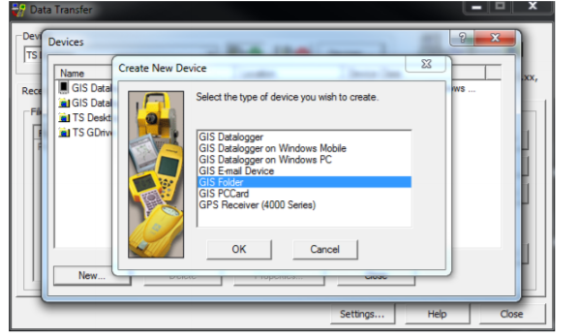

- Select the lettered drive that is associated with the device:

- Choose TerraSync as the file Type, and select the TerraSync version v3.xx, v4xx., v5xx:
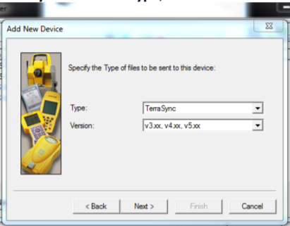

- Specify a Name for Device – We recommend using syntax like this: “USBConnection – E:drive”. In this case, this specifies, the connection is over the E:drive. 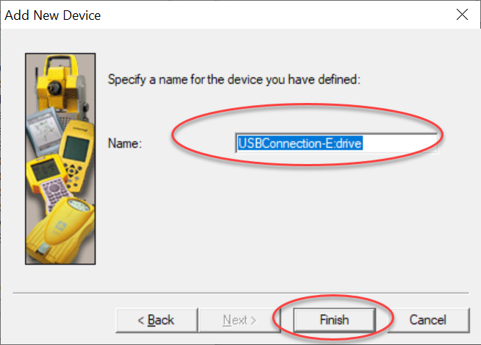

With these settings applied, you can use Data Transfer to send files directly to and from the SD card.
CONGRATULATIONS – You have now circumvented WMDC forever more.

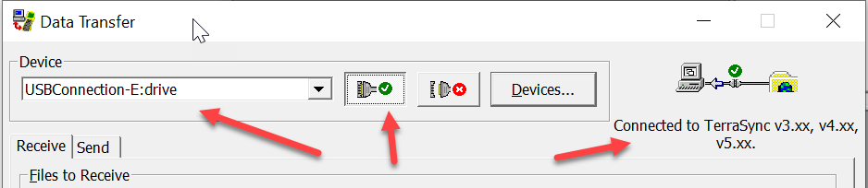

Transferring Studio and Coordinate System files
You cannot transfer Studio files or coordinate system files using the GIS folder option and USB Switcher App. This is because both STU/CFG/TCF files that control the configuration of TerraSync and CSW files are directed to the exact location on the Trimble only when using Windows Mobile Device Center and Windows Device option in Data Transfer. If you want to send Studio Files or add custom coordinate systems that are not available in the version of TerraSync you have installed, follow these instructions:

A – Transferring Studio Files including Configuration files

- Create Studio Files using Positions Studio or Pathfinder Office Studio file app
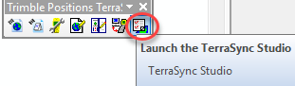

- Select Data Tab and turn off all Generic Features. This ensures you eliminate these three features as the “default” Generic Features. We recommend you always use the CORE point, CORE line and CORE polygon features for all your “generic collection”

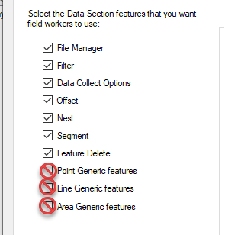

- Save As TerraSync.stu. This file must be saved as TerraSync.stu or this procedure will not work to configure TerraSync on the device.
- Close Studio app.
- Choose a folder on your PC and copy the TerraSync.stu file and select Save.
- Copy the file(s) to the Windows Embedded Handheld device (e.g. via the SD Card Mass Storage connection).
- On the Windows Embedded Handheld device, using File Explorer move the file to the My Device / My Documents / TerraSync / Configuration folder.
- When asked if you want to overwrite, select Yes.
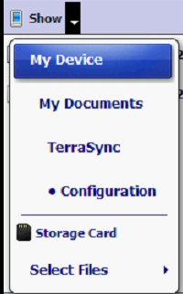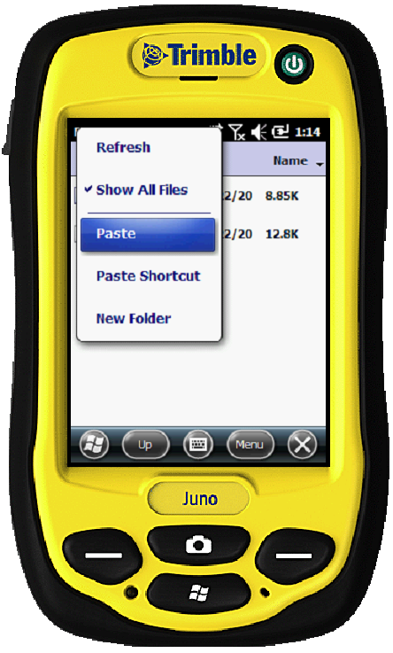

NOTE: This manual copy / paste and overwriting of existing TerraSync.stu file will take effect when TerraSync is launched every time on this device. The Alaska Region GIS Team recommends this is done for all devices in your fleet. It is essential however to place the 3 CORE Point, Line and Polygon Generic features into each DDF you create so the field user has an “opt out” set of features to collect something they encounter in the field that is not anticipated. WE DO NOT WANT folks entering data into the Trimble generic point, line and poly features since there is nothing stored in those except a comment field. Alaska GIS wants everyone to use the CORE Data dictionary. Edit for your Park, and sprinkle it throughout your receivers. Download the CORE from here. http://inpakroms03web/rgr/akgis/index.cfm?action=dsp&topic=gps&item=professional

B – Transferring Coordinate System files:
Using CSW files allow for example to collect data in Alaska Albers NAD83(2011) and orthometric height (using a Geoid file) in the field.
- In GPS Pathfinder Office, open Utilities / Other / Coordinate System Manager.
- Select the Coordinate System you want to export (if you want to use only the selected coordinate system).
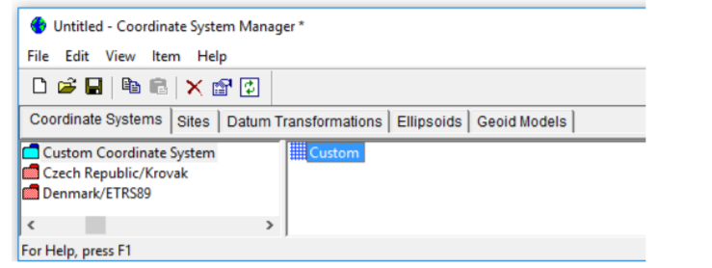
- Select File / Export, and rename the file to complete.csw.
- Choose a folder on your PC and select Save.
- Copy any related required files (e.g. geoids) to the same folder.
- Copy the file(s) to the Windows Embedded Handheld device (e.g. via the SD Card Mass Storage connection).
- On the Windows Embedded Handheld device, move the file(s) to the Program Files / Common Files / Trimble / GeoData folder.

APPENDIX A. Devices NOT Compliant with USB Switcher App
There are several of the older collectors, GPS data loggers that due to the older version of Embedded Windows Mobile will not work with the USB Switcher App. Here is a Table of devices and recommendations moving forward for data transfer. Sadly, some of the most hardened collectors with RS232 ports are not setup for easy data transfer without Windows Mobile and should be on the list for replacement in 2020.

Device | SD Card Slot? | SD Card Slot Location | Data Transfer Options | Photo
GeoExplorer 2008/3000 Series Handheld (2003) | Yes. | Under SD card cover on bottom of device. Easy to access. | Manual ^{1,4}  Must install the SD Card Recognition CAB File – March 2011 See here | 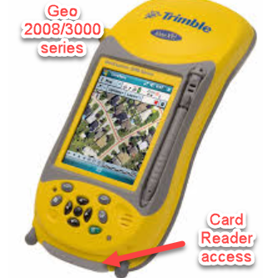
Nomad 900G Series (2012) | Yes | Underneath top cap but hard to access. | Manual ¹ | 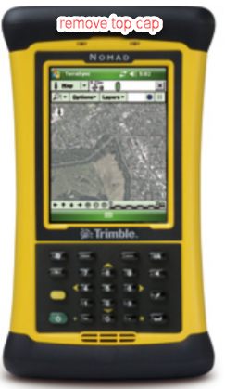
Nomad 1050 Series ² | Yes | Underneath top cap but hard to access. | Manual ^{1, 2}
Nomad 800G Series (2009) ³ | Yes | Underneath top cap but hard to access. | Manual ^{1, 3}

*1. Manual transfer SD card reader must be accessed under bottom card reader access cap. SD Card reader required.
*2. LC,LE,XC,XE models - microSDHC slot; B,L, X models - SDIO/SDHC. SD Card reader required.
*3 800LE,800LC models – SD; 800L,800B – SD/Compact flash. SD or CF card reader required.
*4. Must install the SD Card Recognition CAB File – March 2011 See here
References and Links

GNSS POS NAV HOW to’s site
https://doimspp.sharepoint.com/sites/npsgnssposnav/SitePages/how-to_mobile.aspx

NPS Alaska GPS Page where this and CORE Data Dictionaries are stored.
http://inpakroms03web/rgr/akgis/index.cfm?action=dsp&topic=gps&item=gps

All in-one guide on conducting Hard resets. https://www.blm.gov/sites/blm.gov/files/Factory%20Reset%20Instructions%20for%20Common%20Mobile%20Devices.pdf

SD Card compatibility matrix
http://trl.trimble.com/docushare/dsweb/Get/Document-390286/MGIS_SprtNote_FieldComputers_SD_cards.pdf

How to transfer TerraSync files without the USB Switcher App. This would apply for those like GeoExplorer 2008/3000 receivers.
https://www.youtube.com/watch?v=VNuwdKMD1bc

Revision History
Date Modified | Revised By | Changes Made
2020-02-28 | Joel Cusick | Document Created
2020-03-01 | Joel Cusick | Document Revised
2020 – 03-04 | Joel Cusick | Document standard applied
2020-03-13 | Joel Cusick | Simplify the file copy from card to device
2020-03-16 | Joel Cusick | Added applicability to TSC3
2020-03-18 | Joel Cusick | Added appendix for NOMAD and non-usb switcher app devices.
2020-03-27 | Joel Cusick | Links to sharepoint site
2020-04-01 | Joel Cusick | More precise steps for Geo6000.
2020-05-10 | Joel Cusick | Added Waypoints and Studio File transfer
2020-06-09 | Joel Cusick | Tighten language for manual copies of STU files

