Session 3 – Working with Point Clouds and Trimble Stratus Data

Provided Data Files
- Reservoir Survey – Feb 2017
  - Ortho Photo in JPG/JGW format
  - Point Cloud in .las format
  - Other Data
- Reservoir Survey – April 2017
  - Point Cloud in .las format
  - Other Data
- Reservoir – Boundaries
  - A number of DXF Boundary Files
- Color Maps for Cut Fill and Elevation Maps
  - Assorted Elevation and Cut Fill Color Maps
- Example BC-HCE Project FIles

Exercise Summary
In this exercise we will work with Trimble Stratus generated data for one of the projects that we have been doing locally. In the session, we will review two data sets one from February 2017 and the other from April 2017 with the goal of analyzing the movement of material between the two surveys. We will use Business Center – HCE to
- Setup a Business center Project to model point cloud data in an optimal way
- Import the point cloud data
- Clean and validate the point cloud data
- Import the Aerial Imagery
- Model the data for the two surfaces
- Review the models in plan, 3D and Surface Slicer views
- Use the new Create Volume Grid command to compute volumes at different grid spacing’s
- Use the new Create Volume Grid command to compute volumes of specific areas of the project
- Review how to use the Color Mapping command to create a custom color map for the Cut Fill Maps created using the Create Volume Grid Command
- Learn how to use the Point Cloud Region Command
- Learn how to use the Classify Point Cloud command
- Learn how to eliminate unnecessary / unwanted data from point clouds
- Learn how to model a surface using areas with different point densities for increased / decreased accuracy / fidelity
- Understand how point clouds are handled and used in BC-HCE

Menu Ribbons Required
- File
- Project
- View
- Edit and Query
- CAD
- Image and PDF
- Point Clouds
- Feature Extract
- Surface
- Support

Exercise Details
- Open a new US Feet Project using the US Foot Site Takeoff Lite (Master) template
- Let’s review the settings that you should have for working with Point Cloud data
  - Open the Support – Options – Point Clouds function
    - Set the Maximum Number of Points in surface definition = 100,000 or 250,000
    - Set the Maximum Number of points in volume measurement = 200,000 or 500,000
    - Set the Maximum Number of Points in spatial sampling algorithm = 10,000,000
    - Set the Rendering memory cache size in GB = 2.0 GB (assumes you have >8GB RAM available on your PC)
    - Check the copy Point Cloud files to the project folder on import check box
  - We will review why you do this
  - We will discuss how BC-HCE works with Point Clouds
- Import the Fiore Reservoir – Feb 2017 Ortho Photo (drag and drop). This will create a Georeferenced Image in the View Filter Manager.
- Turn off the Georeferenced image
- Import the 02 - Reservoir – Feb 2017 .las point cloud (drag and drop). This will create a Scan and a series of Point Cloud regions in the View Filter Manager. The Trimble Stratus team when the service creates the Point Cloud run tests on the data and “classify the point cloud into regions”. Those regions are Ground, Low Point (Noise), and Never Classified. Business Center –HCE uses a Region called “Default” as a catch all for unclassified point cloud data.
- We will first regroup all of the data into a single Point Cloud Region called “February 2017 Survey”. Use the Point Cloud Menu. Make sure that rectangle select is highlighted. Draw a selection rectangle around all of the Point Cloud data.
- Once the point cloud data is selected, Select Point Cloud – Create Region and then name the Region February 2017 Survey
- Now repeat steps 5 through 7 for the April 2017 Survey.
- Let us now review some of the Point Cloud functionality for visualizing Point cloud data.
- You will now have two point cloud surveys that we want to create two TIN surface models from.
  - Use the Surface – Create Surface command to model the Feb 2017 Survey point cloud. Classify the surface as a Work In Progress Surface and set the date for the surface to Feb 17 2017 at 5:00:00 pm.
  - Use the Surface – Create Surface command to model the April 2017 Survey point cloud. Classify the surface as a Work In Progress Surface and set the date for the surface to April 17 2017 at 5:00:00 pm.
  - Let us now review the created surfaces.
- First let’s run a surface to surface volume on these surfaces. Before doing so we will review Project Settings – Computations – Surfaces. When computing volumes from Point Cloud data we can change the way we compute the volume isopach, to better suit the source data. When working with point clouds typically set the setting called Volume Computation to the value Do Not Track Breaklines. Now run the surface to surface volume computation (bear in mind that this is two surfaces both containing ~100,000 points. The volume results should be similar to the following
  - Cut Material = 904683.1 cy
  - Fill Material = 660722.5 cy
  - Excess = 243960.5 cy
  - Cut Area = 8631207 ft2
  - Fill Area = 4285887 ft2
  - Zero volume area = 10.2 ft2
- Now we will run the same volume computation using the Volume Grid commands.
- From the Surface menu, select Volume Grid and Enter a name for the Volume Grid as Feb – Apr Volume Grid 10’ Interval. Pick the Feb 2017 Survey as the initial surface. Pick the April 2017 Survey as the Final Surface. In the first pass, do not select any boundaries. Set the Grid Spacing to 10’. Set the Rotation to 0. Let the computation run and then write down the results or copy and paste the results into Notepad. Note if you set a command shortcut for Center as CTRL C, Copy / Paste will not work.
  - Cut = 905580 cy
  - Fill = 661864 cy
  - Excess = 243715 cy
- This process creates a section called Stored Measurements in the View Filter Manager. Each Grid Volume you create creates a new entry in that section. These are equivalent to a Cut Fill Map. You can color these using your own Cut Fill Color Map schema. They have reviewable properties (which include the results of the volume calculations). We have provided you a number of Color Schemas that you can use for color shading the difference models.
- Let us review the properties of the Volume Grid process
- Let us review the graphical properties of the Volume Grid process
- Let us compute a second volume grid using a different interval – this time select a grid interval of 5’. Then repeat the process with a 20’ grid. What differences are you seeing? Spread over the whole area of the project, what does that volume difference represent?
  - 5 Foot Grid
    - Cut = 905730 cy
    - Fill = 661689 cy
    - Excess = 244041
  - 20 Foot Grid
    - Cut = 905085 cy
    - Fill = 661406 cy
    - Excess = 243679 cy
- You can compute grids up to ~3,000,000 grid cells efficiently with this method. Try 2.5’.
- Notice how quickly the grid volumes compute. See below the differences in the volumes using the different methods of computation.
Results Compare | TIN | 5' Grid | 10' Grid | 20' Grid
Cut | 904683 | 905730 | 905580 | 905085
Fill | 660722 | 661689 | 661864 | 661406
Excess | 243960 | 244041 | 243715 | 243679
Cut % (TIN Truth) | 0 | -0.12 | -0.10 | -0.04
Fill % (TIN Truth) | 0 | -0.15 | -0.17 | -0.10
Excess % (TIN Truth) | 0 | -0.03 | 0.10 | 0.12

- Now we will look at a few more points relating to Point Cloud handling if we have time.

Exercise 2 – Variable Density Modeling Using Point Clouds

Overview
Modeling Large Surface Areas at the same point density extracted from Point Clouds will not necessarily give you the surface models that truly represent what you are trying to deliver. Most Projects will have areas where there are a lot of surface changes going on where you may want to model the surface with more data points per unit area and then areas e.g. Landscape Areas where modeling at a lower Point Density per unit area will suffice. The key to this is knowing where those High Density (HD) and Low Density (LD) areas are and delineating them with boundaries that can be used to create Low and High Density Point Cloud Regions.

Current Workflow Shortfalls
In the current release product, the only way to create a Point Cloud Region is to use the Polygon Select method to draw a polygon “freehand” to define an area that you want to make a Point Cloud Region. In a future release there will be a tool that allows you to select by pre-defined polygon. Until that release, you will need to create the polygon areas and then trace those areas out using the Polygon Select Tool to create the Point Cloud Regions.

Current Workflow Benefits
In the current release Point Cloud support, the number of points from the first Point Cloud region selected that will be used to create a surface is defined under Support – Options – Point Clouds. If you select e.g. 100,000 points as your setting then when you select one point cloud and create a surface from it, the surface will have 100,000 of the total number of points in the original point cloud added to the surface. If you then add a second Point Cloud Region to the Surface using Add / Remove Surface Members, then 100,000 points of that second point cloud region will be added to the initial 100,000 points from the first point Cloud Region.
Note: This approach only works this way when you add each point cloud individually to the surface created from the initial Point Cloud Region. If you select two point cloud regions to create your initial surface than you will only get a total of 100,000 points in the surface model, extracted from the two point cloud regions (the two point cloud regions are merged in background and 100,000 points extracted across the total point cloud region at a uniform density).
Note: If your first Point Cloud Region covers a Large Area and your Second Point Cloud Region covers a significantly smaller area, then the point density of the second area will be much higher because you will be extracting 100,000 points from a much smaller Point Cloud Region (in terms of number of points). This may in itself suffice to create a higher density surface in the HD area of the project.
Note: If between the addition of Point Cloud Region 1 and Point Cloud Region 2 you go to Support – Options – Point Clouds and change the Number of Points to include in a surface to e.g. 200,000 then when you add the second point cloud region to the surface using Add / remove Surface Members you will now add 200,000 points from the smaller HD Point Cloud Region to the surface – further increasing the point density of the surface model in that area. The Point Cloud settings are only applied when you add a point cloud / point cloud region to a surface model, once added the only way that you can change the density is to remove the point cloud region from the surface, change the setting and then re add the point cloud region back to the surface (thereby adding it at a higher point density.

Exercise Steps

- Following on from the previous exercise and continuing to use the Reservoir survey data we will work with the Feb 2017 Survey point cloud. Switch the other scans off for the time being.

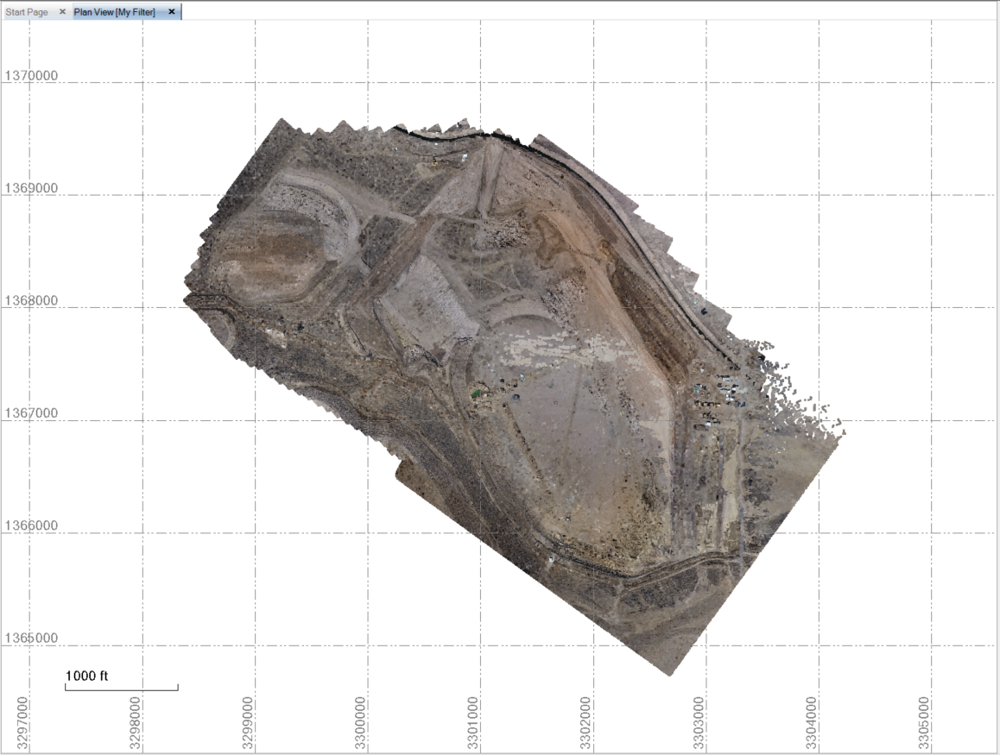

- Use the select by Polygon method to extract the High Definition Area as shown below

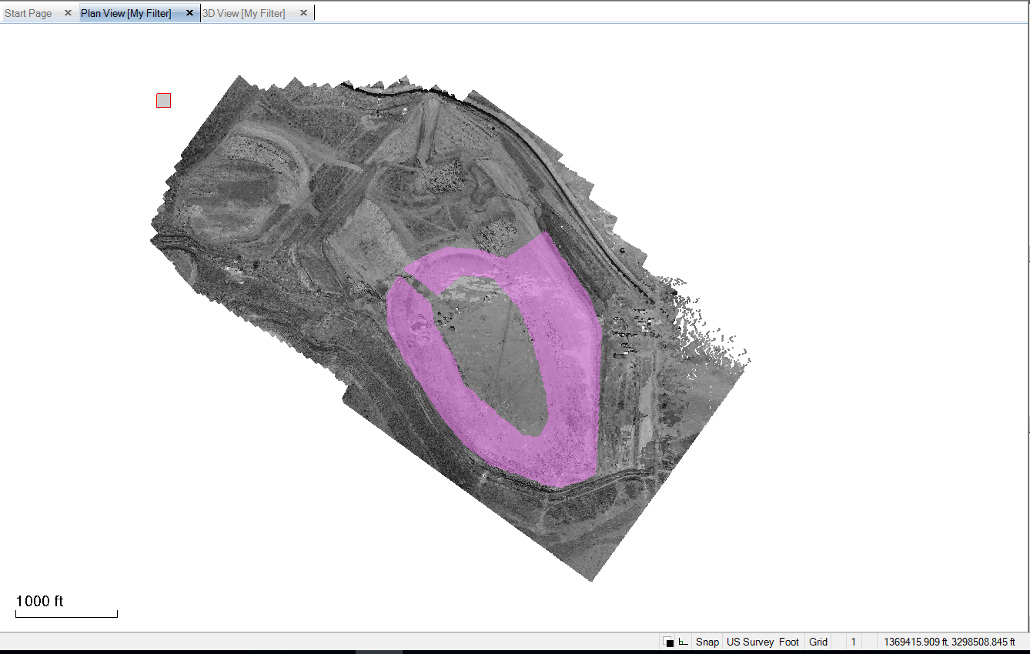

- Use the Create Region command to create a new Point Cloud Region called Feb 2017 Survey - HD Area
  - If we review the properties of these two point cloud regions now we will see the following
    - The Low Density Area Point Cloud has 10.668 million points and covers a large area
    - The High Density Area has 2.441 million points and covers a small area

- Set your Point Cloud Settings under Support - Options to allow the Point Cloud Surface to have e.g. 100000 points in it

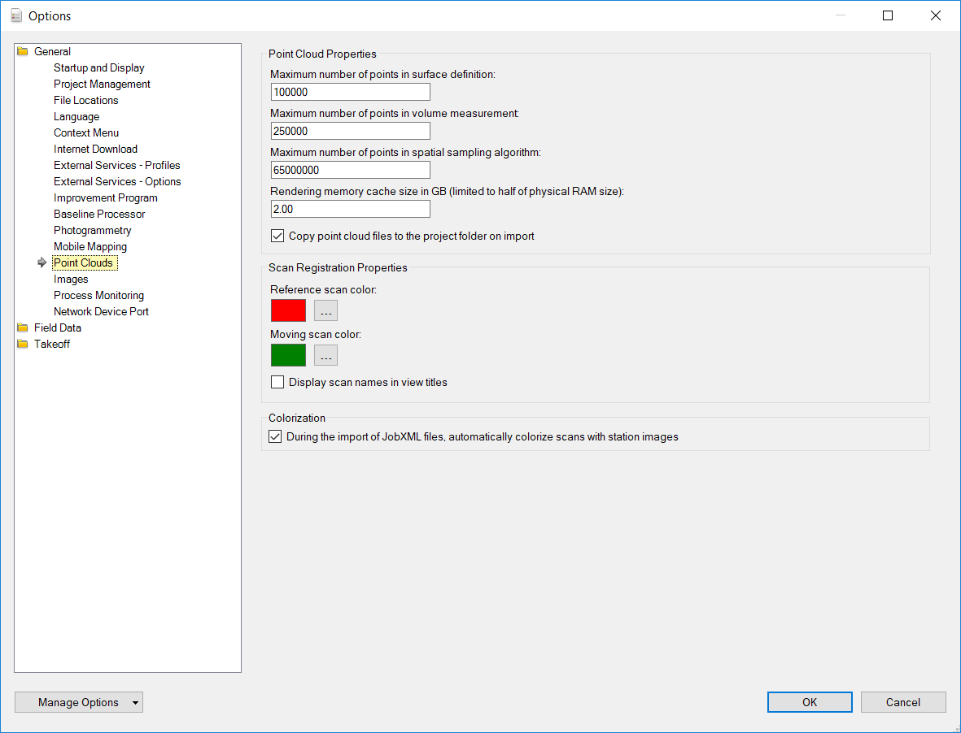

- Create a Surface Model called Feb 2017 Survey (Mixed Density) from what is remaining of the Low Density point cloud (this will have holes in the surface that are filled across by triangles that we will later replace. In this step you will add 100,000 of the Low Density Point Cloud points to the surface model.

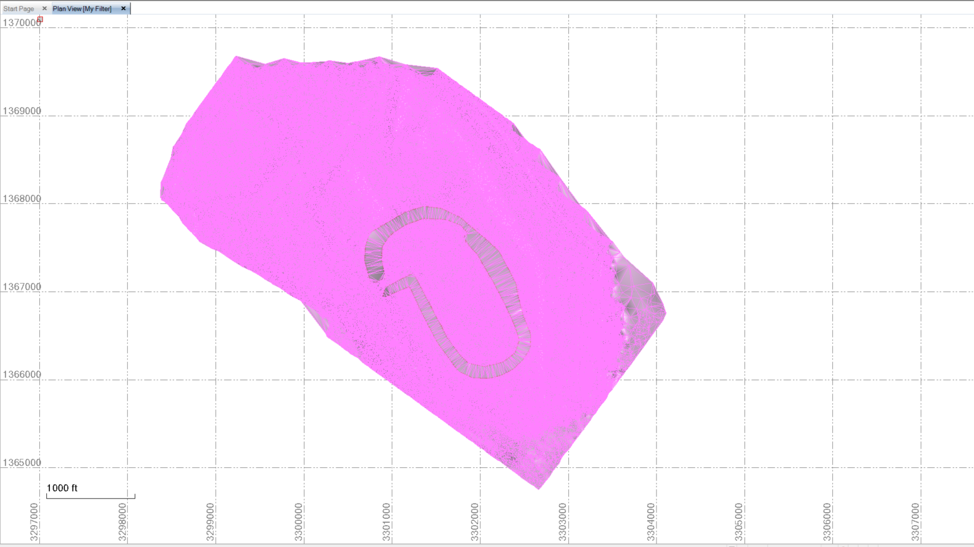
Note in the HD Area there are few triangles

- You can either leave the Point Cloud Settings as they were (100,000 points in a surface model) or you can change the number of points now to extract more or less from the second area that we are about to add as the HD area of the surface. When we add / Remove Surface members to add a second point cloud region to the Mixed Density surface model, it will use the current point cloud setting to extract that number of points from the second point cloud region to the existing surface of 100,000 points. Because the second area is much smaller than the full survey area, selecting 100,000 points from the smaller area will itself result in densification of the model in that area.
- Add the HD Point Cloud Region to the surface model using Add / Remove Surface Members

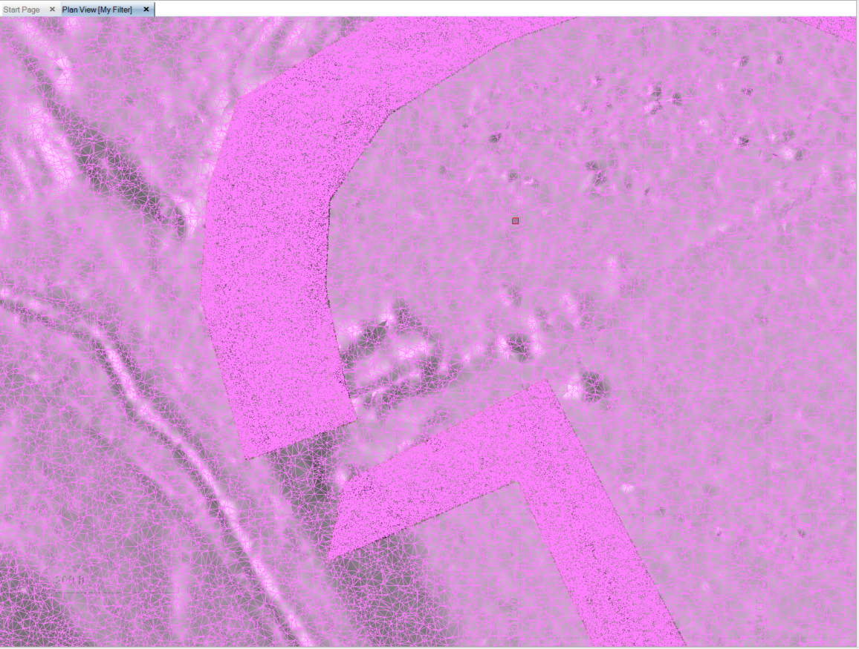
Note that the HD Area now has a much higher density of triangles

- You can add more Point Cloud Regions individually (one at a time) for the other HD areas to build out the composite model with varying densities as you see fit.
- If you review the properties of the composite surface you will see that it now has ~200000 points in the model.

This process allows you to pick out areas of the job where you expect e.g. vertical or near vertical jumps in the data or where you have a lot of surface shape changes going on and model them at High Density and leaving the large landscape, less irregular or less critical areas at a lower density.
This is a tremendously powerful method to build out what you need for a model - it will be better still when the "Create Point Cloud Region by Boundary" command is available (saves having to trace out your polygon areas from flight to flight).

Exercise 3 – Feature Extraction from Point Clouds
This exercise was driven by a request from a contractor that is using Scanner technology extensively in the construction environment on UDOT highways projects. One of the requirements that UDOT puts on their contractors at Pre Construct stage is that they require point data to be provided at 10’ Stations along the centerline at the following locations on all Bridge improvements
- The bottom of the barriers on the left and right side of the bridge
- The top of the barriers on the left and right side of the bridge
- At a 1 foot offset to the bottom of the barrier on the pavement on the left and right side of the bridge
The customer request was for us to show them how they could meet this requirement in Business Center – HCE using the tools that we currently have available.

Provided Files
- Project Template – US Foot Site Takeoff (Master).VCT
- Point Cloud File – Bridge 2 (Markings).LAS
- Example Projects – Start and End Point.VCE

Exercise Steps
Following on from the previous exercises, we will now use those to execute this process and explore some additional functionality available.
- Start a new project using the Template US Foot Site Takeoff (Master)
- Import the Bridge 2 (Markings).LAS file by drag and drop into the graphics
- You will find that the scan data points are colored white by default, so you may not be able to see them on a white background – change your background color to Black or change the rendering of the point cloud to “Color Coded Intensity”.
- Review the properties of the imported Point Cloud and you will find the following
  - The point cloud contains 134.5 million points
- Review the Point cloud in plan and 3D – you will find the following
  - that there is “noise” in the dataset that needs to be removed
  - That there are two bridges and therefore 4 barriers for us to extract features from
  - That there are white line markings down the centerline of each bridge that we can use to create alignments (since we do not have the alignment for this project.
- Use the Extract Ground function on the point cloud to see if it can remove that noise
  - Discuss the findings
    - The Barrier data is left in the “Unclassified” point Cloud Region and needs to be added back to the Ground Point Cloud Region to get the data that we need.
    - It did a really good job of extracting the noise on the pavement areas of the project
- Undo the Extract Ground and try the Classify Regions function to see how it does with the same data. Switch off the Buildings Class as there are no buildings in this data.
  - Discuss the findings
    - The Ground Point Cloud Region is pretty clean but is missing the Barriers now – they are left in the Unclassified Point Cloud Region and will need to be “Added Back” to Ground.
    - The Poles and Signs point cloud region has picked up some of the noise created by passing traffic.
    - The Unclassified point cloud region has much of the “noise” data as well as the Barrier data that needs to be added back to the Ground Point Cloud region.
- Which method should we use to Get as clean a data set as possible?
  - Conclusion – either one works to speed up the process, both give similar results.
- Adding data back from the Unclassified Region to the Ground Region
  - Use the polygon select method to select the barrier data
  - Use the Add to Region command to add the selected barrier data to the Ground point cloud region
  - Repeat steps till you have got the ground data to be as we need it for the exercise
- Now you likely want to reduce the Ground Point Cloud Region to just the data that you need to work with – i.e. the Bridge itself to the limits of the barriers and remove all additional data outside of that before doing a final clean on the Ground Point Cloud.
  - Select some of the data that you want to eliminate using Polygon Select method
  - Create a Point Cloud Region called “Bridge 2 (Markings) Unused”
  - Turn off the Unused Point Cloud Region so you know that it has gone
  - Continue selecting unnecessary data and use the Add to Region – adding each selection to the Unused point cloud region
- In my example, having eliminated all the areas that are of zero interest to me for the exercise that I have to execute I have reduced my Point Cloud size down to ~65 million points (less than 50% of the initial point cloud).
Comment / Observation
I have found that when extracting feature data, it is best to use as much of the relevant source data as possible on screen during the feature extract process. For this reason, and depending on your computer specification (disk type, available RAM, processor speed, Graphics Card and Graphics memory), you may want to extract the Left and Right Barrier of each bridge into separate point cloud regions and then process each separately – so that you can maximize the data displayed on screen.
This also eliminates data in the background that could be snapped inadvertently while working
When working with scan data, in situations like this example, the further you get from the scanner setup location, the less dense the data becomes, and therefore the harder it is to automate feature extraction. The feature extraction methods of Business Center – HCE depend upon the number of points displayed vs the number of points in the point cloud itself. Reducing the point cloud regions to e.g. Left Bridge Left Barrier etc. minimizes the number of points in the point cloud region allowing you to maximize those that are displayed on screen while extracting features.
- We are only going to do one of the barriers in this exercise, so let’s extract the Left Bridge and then from the left bridge let’s extract the Left Barrier. Create Point Cloud regions for Left Bridge and Left Bridge Left Barrier. For the Left Barrier be sure to leave a couple of feet of the pavement so that we can extract the 1 ft. line as required in the specification.
- My Left Bridge – Left Barrier Point Cloud is now only ~2.5 million points. The Left Bridge point cloud region has ~30.4 million points in it. If we are only interested in the area around the Centerline we could also extract a smaller region around the centerline so that we can display more of the points in that area while extracting the centerline itself. In my example I did this and now have only 2.7 million points in the central area of the pavement model.
- Now we can optimize the point cloud settings for our PC to meet the requirements of this exercise. Because any one point cloud region has less than 3 million points now, we can set the Support – Options – Maximum Number of points in a spatial sampling algorithm to 4000000 provided that we only have one of the regions displayed on screen at any one time. If you have a lot of RAM on your PC (32GB or 64GB) you can allocate 8GB to the Rendering Memory cache size to speed up display regeneration as you move around in the point clouds.
- The next step is to either create or extract a centerline from which we can compute 10’ Stations on which we are expected to supply point data for the requested feature lines. Because we don’t have an alignment, we are going to draw one into the data using the white line markings in the point cloud data. You should turn on the Left Bridge or Centerline Area point cloud region to do this so that your alignment lies within the limits of the point cloud region. You will have to “eyeball the first and last points since the line markings stop prior to the edge of the point cloud region and don’t exist in any of the other point cloud regions that you extracted. You can adjust the first and last points of the line using Bearing and Distance from the 2nd and last but one point nodes that you extract from the centerline markings.
- When extracting White Lines, it is typically best to use the Point Cloud Rendering Setting for Grey Scale intensity as that highlights the white lines best. With true color scans, the scan color also works well. Color Coded Intensity can also work well due to the reflectance of the white lines.
- Use the Linestring command to create a linestring down the centerline of the point cloud. We will then convert the linestring to an alignment.
  - Name the Linestring – Left Bridge HAL
  - Put it on layer EXTRACT – Center Line
  - Tap OK to start creating the linestring
  - Eyeball the first point near the SW corner of the point cloud where you think the alignment would be. Then for subsequent points, select points on the white line markers until you reach the end of the bridge where you will again eyeball the last point of the line. The Linestring command snaps to point data in the point cloud, so stay zoomed out so you can see the striping clearly and snap as close to the center of the stripes as you can. We will also look at Feature Extract tools for line markings as a second step.
  - You may also find that using a mix of Grey Scale and Color Coded Intensity may help you in areas where the point density is lower as white lines give a string reflection that helps in the color coded intensity mode.
- Let’s also take a look at the Feature Extract tools that are available while drawing a Linestring.
  - Turn off the layer EXTRACT – Center Line (in the 20-Feature Extraction Group)
  - For now, place this new line on the layer EXTRACT – Other (we will delete it later)
  - For the first and last point eyeball it like last time
  - For the second and subsequent points, next to the Coordinate field of the Linestring command, you will see an icon that looks like this . This is the Point Cloud Feature Extraction Assistant tool. Tap the icon. A Point Cloud Smart Picking tool pops up. The tool provides several options – it looks for specific patterns of points in the area of the click to see if it can identify the most probable location of the required feature. The options here are
    - Default
    - Face of curb (The face of curb / top of curb join line)
    - Gutter (the flow line of a curb and gutter where face of cub meets pan of curb)
    - Roadmark (a white line edge – note the edge not centerline)
  - Select Roadmark in the smart picker and select a point in the right of center of the road marking where the edges are relatively clearly defined. The smart picker will identify where it thinks the nearest right edge of the marking is with a red cross. You can move the red cross in the smart picker if you think you can see the true location better. Tap [Validate] when happy with the solution. Repeat this for as many points as you wish along the alignment.
  - For the last point you may wish to use Bearing and Distance and extract the Bearing from the last segment you created by using SHIFT and click on the line segment near the last point you created. Then for the distance you can snap near the edge of the point cloud to get a distance.
  - You may also want to adjust the coordinate of the first point on the linestring using the Bearing of the second segment and the distance to the edge of the point cloud.
  - You can check the profile of any linestring to ensure that the selected points are “clean” and that the profile makes sense. To do this, select the linestring, right click and select Profile Viewer.
  - You will see that the Smart Picker is very good when the data is densest, and less useful at the limits of the scans where the data is less dense.

In the above process, you will see that while drawing a linestring within a point cloud, that it is snapping to the nearest point in the Point Cloud at all times, this ensures that the linestrings are truly 3D.

We now need to turn the centerline linestring into an alignment – You can decide whether a freely selected linestring where you were snapping to the middle of the striping, or whether a Left or Right Edge of striping using the smart pick function is the best linestring to define the centerline.

- Run the Create Alignment command and name the Alignment Left Bridge HAL. Click the Use an existing line check box and then select the linestring that you just created.
- Now you likely want to label the alignment at 10’ stations so that you know where your point data (for the deliverable) will be created at the last stage of the process. Select the alignment and then right click and select Edit Alignment Labels, then tap OK to create them.
Now we will proceed to creating the Bottom of Barrier line where it meets the pavement. We will use Free Snap and Feature Smart Pick in this process, depending on the density of the source point cloud at different locations.
- Turn on the Left Bridge Left Barrier Point Cloud region
- Run the Create Linestring command
  - Name the feature line Barrier – Bottom
  - Place it on the layer EXTRACT – Barrier Bottom and tap OK to start creating
  - In the coordinate field, select the Point Cloud Smart Picker and then select the picking type Gutter. Note, if the smart picker is not working with the density of data available, switch it back to default until you see the point density increase again. You can select in Plan or 3D Views.
  - You can repeat the process for the top of barrier, picking where the rounded corner flattens out on the top of the barrier as the reference point. In this case use the Face of Curb Smart Picker. Call the Feature Barrier Top and place it on the EXTRACT – Barrier Top layer. You will find that because of the rounding – the smart picker will not find these points easily – you will likely need to use the Default and free snap the points along that break in the barrier.
  - Lastly the 1 Ft Offset line. This is the trickiest one to find. My recommendation in BC-HCE is to use the following method
    - Use the Offset Line command to create a line at 1’ offset to the Bottom of barrier line so you know where it will be graphically. Name the line Left Bridge Left Barrier 1 Foot. Place it on the EXTRACT – Barrier 1 Ft layer.
    - Digitize one more line inside of the Bottom of Barrier line that you created first, and before you get to the 1’ offset line you just created. This line will lie 100% on the pavement surface. Call it Pavement Edge and place it on a New Layer called EXTRACT – Pavement Edges
    - Make a Surface TIN Model for the Pavement surface using the linestring that you extracted at the centerline and the linestring you created for the pavement edge. Call the surface Left Bridge Pavement and classify as Original. Give it a color Green.
    - Now we will take the 1’ offset line and change its elevation first to Undefined to remove all elevations and then to the Pavement surface that you just created.
      - Run the Change Elevation command
      - Select the 1’ Offset line
      - Select Undefined elevation and then Apply (this makes it 2D)
      - Select Surface elevation, Set the Delta elevation to 0 and select the Left Bridge Pavement surface model. Tap apply to elevate the line.
      - Now you can Add the 1’ offset line, bottom of barrier and top of barrier lines to the pavement surface model and remove the pavement edge line from the model using Add / Remove Surface Members.
- To create the deliverable point data every 10’ along the three defined feature lines you can use the Station, Offset, Elevation report and output the data to Excel. You can there delete the point data extracted where the 10’ station lines intersect the TIN model edges leaving just the points that are required along the 3 strings.
  - Run the Station, Offset, Elevation Report
  - Select your alignment (Left Bridge HAL)
  - Select Start Station 0
  - Select End Station (end of alignment)
  - Select the Surface Cross Sections method
    - Surface – Left Bridge Pavement
    - Left Width and Right Width leave at -300 and 300
    - Station interval = 10’
    - Check the Slice at even stations checkbox, and leave the other check boxes blank
    - Check the Include northing/easting checkbox and leave the other check boxes blank
    - Select the Load data into Excel radio button
    - Tap OK to execute
  - The report will open in Excel. It will need a little cleaning before it can be used.
    - Delete Line 1
    - Highlight the new Line 1 and select Data – Filter
    - In the Point ID field, deselect all of the filters except Left Bridge Pavement (these are the nodes computed at the 10’ stations where the section slices the TIN model edges. Select all of these lines and delete them
    - Reset the Filter to show all types.
    - Delete the Station and Offset columns
    - Move the Elevation Column so that it is after the Easting column
    - Copy the Point ID column data to the Feature Code Column
    - Create Point IDs starting at 1 and ending at whatever number is the last point
    - Save the Excel file as a CSV file (P,N,E,Z,D format) in the Exercise folder – call it Left Bridge Left Barrier Points.csv
    - Now import the file back into the project. Use the Format P,N,E,Z,D (Unknown), and make sure that your format definition has 1 header line set to skip. Select the Layer EXTRACT – Points for the imported point data.
    - You now have the deliverable point data for the first barrier.
A second deliverable required by UDOT is to generate Profile Drawings of the Top of Barrier and 1ft offset lines for each barrier on each bridge. We will address this in the Plotting and Drafting Session on Day 2.
If you want to run this process on a second barrier to consolidate your learning, repeat all of the above steps for the Left Bridge Right Barrier.
There are some additional functions that can be useful for feature extraction. The following exercise continues from the above Left Bridge Left Barrier exercise.

Creating Cross Sections Through the Barrier
If for example we wanted to create cross sections through the barrier at approximately 10’ intervals (this would work better if the tools here used the alignment as the baseline) however currently they only work to a straight line baseline, or you can create or modify the cutting planes that we will be using at each station you require to create a section.
- Turn on the Left Bridge Left Barrier Point Cloud Region
- Turn on the Left Bridge HAL alignment and the Alignment Labels
- Turn on the Extract – Points layer
- Turn on the EXTRACT – Sections layer
- Turn off everything else
We will be using the Cutting Plane function to draw cross sections in a cutting plane at each of the required station locations.
- Select Plane Definition Manager from the Feature Extract Menu ribbon.
- Tap New to create a New Cutting Plane
  - Name the Plane, Plane 1
  - Select Vertical Plane definition
  - For Point 1 select the Right End of the Station 0 Label Tick mark
  - For Point 2 select the Left End of the Station 0 Label Tick Mark
  - For Position select the Right End of the Station 0 Label Tick Mark again
  - Close the Plane Definition Manager
- Select Cutting Plane View from the Feature Extract menu ribbon.
  - Plane 1 is the only Plane defined at this stage
  - For Offset, leave it at 0
  - The Apply Cutting Plan Check box should be marked
  - For Cutting Plan Thickness set it to e.g. 0.1’ (this selects data parallel to the station label tick mark within +/- 0.05’ up and down station. Where the scan data is densest you can use a smaller value and where it is least dense you may need to widen the Cutting Plane Thickness to capture enough of the point cloud from which to trace the section. Bear in mind however that when you have a wider plane definition, your section can snap to points further from the desired station – it does not pull the data onto the cutting plane itself.
  - You should now be able to see the outline of the Barrier and Pavement section in the Cutting Plane View. The Cutting Plane View creates a UCS that is parallel to the view. When you draw in the cutting plane view, it creates linework in the UCS but that linework also appears in the correct spatial location in 3D.
  - You can now use tools like Draw Polyline or Draw Linestring in the Cutting Plane View to extract the shape that you want in the model. Draw a CAD Polyline in the Cutting Plane view on Layer EXTRACT – Sections. Name the polyline XSection 1. We recommend using Polyline because a Polyline is planar (has a fixed Z) and in the case of a Cutting Plane View Z is in / Out of the Plane so by default the Polyline is drawn in the plane of the cutting plane. A linestring can have variable Z and therefore can “Zig Zag” back and forth across the plane depending on which point it snaps to while drawing.
  - Review what you created in Plan and 3D Views.
- You will now change the Cutting Plane to the 10’ Station location by Changing Points 1 and 2 and Position in the Plane Definition Manager.
  - From the Defined Plane pull down, select New
  - For Plane 1 – Point 1 select the Right end of the alignment label tick mark at 10’
  - For Point 2 select the Left end of the same tick mark
  - For Position select the Right end of the Tick Mark again
- Now you can draw your second cross section in this plane
- Repeat this process for each cross section that you want to extract
Note:
In each of the cross sections that you create, you will see the points that you created using the first process in the Cutting Plane. From here you can evaluate the accuracy of the extraction method used in the first phase of this process – you will find that typically you will be within a few hundredths of a foot if you use the Measure Tool in the Cutting Plane view.
The challenge with the lines drawn in the Cutting Plane view is that they have UCS and because they have UCS they will not work with many of the Data Prep commands. However, you can use the Draw Linestring command to connect the common nodes between the cross sections that you have drawn. Be sure to either Turn Off the Points and Point Cloud or remove snapping to Points from your running snaps so that you can snap to End Point to join those common nodes in 3D.

Limit Box
The Limit Box function is another useful tool for manipulating Point Clouds. The Limit Box is a 3D Rectangular Box that can be moved, rotated, lengthened, widened, heightened to limit the visible data on screen. Once enabled, the Limit Box allows you to select from the data that is visible only.
For long linear elements, the limit box is an effective way to reduce the data that you are working with on screen without having to first create Point Cloud Regions.
For projects where you may have a specific elevation range that you have to work with, however you may have measured data below or above the specified range, you can limit the limit box Top and Bottom through setting the Center Point Elevation and a Height. For example if the Min Elevation you can use is +38’ and you can select data anywhere above that and your Max Height is say 75’ then the range you have is 75-38 i.e. 37’ so setting the mid-point at 38+18.5 = 56.5 and the elevation range to 37 will set the lower limit at 38 and the upper limit at 75’.You can then create a Point Cloud Region from what is visible in the Limit Box using Polygon select as normal.
For cleaning up a Point Cloud Project – e.g. where you have a Construction Site with Machines, Piles of Pipe and other 3D objects in the Point Cloud that you have to remove to clean up the data, you often cannot get a viewpoint in 3D that isolates only the data that you want to extract into a Point Cloud Region (removing noise from the Ground Surface for example). The Limit Box can again be applied to the Point Cloud, restricting any likelihood of you extracting data that you do not want to extract using the Polygon select method.
To use the Limit Box
- Turn Off the Alignment Labels
- Turn on the Left Bridge Left Barrier Point Cloud Region
- Turn On the Left Bridge Point Cloud Region
- Turn on the Left Bridge Centerline Region Point Cloud region
- Select the Set Limit Box command from the Feature Extract Menu Ribbon
- Use the colored squares to move the Sides or Top / Bottom faces of the limit box (Left click and drag to move them)
- Use the Red Rotation Arrow to rotate the limit box into line with the road model (Left Click and drag)
- Use the Green Sphere to Raise the Limit Box Up and Down (Left click and drag)
- You can enter specific vales into the limit box dialog to limit e.g. the height range etc.
- To Deactivate the Limit Box, press Deactivate
- You can name the Limit Box and then save it so you can recall it later
- Pick a thin slice of the Bridge Model using the limit box
- Do a polygon select of all the data in the thin slice displayed.
- Create a Point Cloud Region called “Thin Slice”
- Deactivate the Limit Box
- Turn Off the Thin Slice Point Cloud Region – you can see that it is restricted to just the point cloud data that was visible at the time you did the Polygon Select.

Other Tools Not Covered in any Detail
- Sample Region
  - By Spatial (nearest points to a grid spacing) (e.g. 5’x5’ Grid)
  - Random (Number of points from total number of points) (Sequence Extraction e.g. 1:10)
- Sample by Intensity (use 80 to 255 to extract e.g. the white line markings)
- Keep In / Keep Out (Note that this basically erases the data from the Graphical memory and can only be returned using Restore or Restore All command.
- Measure Point (To create points from a point cloud in key locations)

Exercise 4 – Rock Face Modeling Using Radial Surface Model Method

Provided Files
- Rock Face Model
  - Alignment in XML and VCL formats (Alignment.vcl, Alignment.xml)
  - Point Cloud File in LAS format - ScanPos003 - SINGLESCANS - 160504_141931.las
  - Archived BC-HCE VCE Project files for reference
Often we are needed to solve the problem of modeling near vertical faces with overhangs for computing volumes that are more accurate or for the purposes of determining e.g. shotcrete thickness sprayed as a protective or binding material layer onto rock surfaces after excavation.
In v3.80, we added the ability to use the Tunnel Surface Model functions to carry out these tasks.
- Open a new US Feet Project using the US Foot Site Takeoff (Master) template
- Import the VCL horizontal alignment and LAS point cloud files
  - Note LAS files need to be defined in metric and get converted to US Feet on import
- For this process to work
  - The alignment has to be truly curvilinear with tangential elements
- Review the point cloud data in plan and 3D views
- We will use the Point Cloud Tools to extract the data that we need. We will use the Polygon select method to select a subset of the point cloud to eliminate the trees outside the construction cut zone. You can do this in the plan or 3D views.
  - Note if working in 3D, when you start a polygon selection, it defines a plane in the axis of your monitor and you cannot rotate the model during each selection. You can however Pan and zoom within that same plane
- You can open the “Mid-Point Project” to pick up from here
- From the Tunnel Menu, create a Tunnel Surface.
  - Name the surface Rock Face
  - Classify the surface as Work in Progress
  - Select the alignment as the horizontal alignment
  - Same for the vertical alignment
  - For the Vertical offset you need to understand a little about the modeling technique – I will present that to you, for now enter the value of 120’
  - For members – initially do not select anything – I will explain why
  - Select OK to create an empty Tunnel Surface
  - Open the properties for the surface
    - For the approximate radius enter 90’
    - For Unwrap from Top say Yes
    - For Edge Length set the value to 50
    - Close the Properties
  - Now add surface members to the Tunnel Surface using the Surface – Add / Remove Surface Members command. Add the remaining Ground based point cloud data to the Tunnel Surface.
  - Review the resulting Tunnel Surface
- Now make a Corridor Model using the Tunnel Surface as either the Existing Ground or a surface instruction within the Road Template so you can fly through the road project.
- Some of the point cloud data removal can be achieved using
  - The Point Cloud – Extract Ground function
  - The Point Cloud – Classify Regions command
- If you do use those commands on the data, you will find that you will need to still “put back” some data that is moved into different point cloud regions.

Exercise 5 – Rock Face Modeling Using Projected Surface Method

Provided Files
- Rock Face Model
  - Point Cloud File in LAS format - ScanPos003 - SINGLESCANS - 160504_141931.las
  - Archived BC-HCE VCE Project files for reference
In v4.10 we also added the new Projected Surface method as another way to model these scenarios. The projected surface method utilizes a defined plane (Vertical or Inclined Plane) onto which all of the data points to be modeled are projected (so that X,Y coordinates are in the plane and Z is offset from the plane) and then triangulated and then placed back in their correct coordinate locations. The TIN model is therefore computed in the plane itself vs the horizontal plane as per a traditional TIN model.
Note the Earthworks Volume command and Cut Fill Map command will work with Projected Surfaces provided that the Initial and Final surfaces are both Projected Surfaces and both are computed in the same projection plane.
The definition of the Plane will determine the outcome of the surface model. These are some things to consider
- Are there any near horizontal ledges (Overhang or Ledge) surfaces that you want to model? If so then the Plane should not be truly vertical but be inclined in order to pick up the ledge.
- If there are both Overhangs and Ledges you will not be able to model both well in the same projected surface
- You are likely to get some errors in the resulting surface no matter how you define the plane unless the surface is fairly uniform – overhangs and Ledges will be the most likely areas of failure
- Projected Surface or Radial Surface method of modeling will give you a better result than normal TIN models on near vertical faces with overhangs and ledges.

Exercise Detail
- Start a new project using the US Foot Site Takeoff (Master) template
- Import the ScanPos003 - SINGLESCANS - 160504_141931.las file from the Exercise folder
- We are only interested in the rock face on the North Side of the Rock Cutting for this exercise.
- Use the Polygon select command to extract that rock face data into a Point Cloud Region called rock Face.
  - My point cloud region had 650,000 points in it
- Go to Support – Options – Point Clouds and set the number of points in the surface to be 650,000 so that we use all of the points from the laser scan.
- Run the Projected Surface command from the Surface Menu Ribbon
  - Call the surface June Rock Surface
  - Make it a Work in Progress Surface
  - Color it Medium Green
  - Set Measured Date to be June 30th 2018 at 5:00:00 pm
  - In order to compute a Projected Surface, we need to define a Plane. The easiest and fastest way to do that is pull down the Plane Definition List and select New Plane Definition.
  - Get the 3D View into a position where you can see the entire length of the surface face and all details that you are interested in modelling – this may mean being slightly above the surface looking down at it at an angle. Select Parallel to Active View to define the Plane that you will use for the model building process.
  - Tap Apply to create the Projected Surface
- Go to Support – Options – Point Clouds and now change the Number of Points in a surface setting to 250,000.
- Create a second Projected surface using the same plane definition as for the first surface you created. Use the same Point Cloud Region and call this surface July Rock Face Model. Set the Date to be July 30th at 5:00 pm.
- The July Rock Face Model will be different to the June Rock Face model because it uses only 250k points vs 650k points.
- Go to Project Settings – Computations – Surfaces and change the Volume Computation Setting to Do Not Track Breaklines. When we do a volume calculation, bear in mind that we will have 650k points and 250k points in two respective surfaces – the volumes calculation and Cut Fill Map calculation will take a little while to compute depending on your PC.
- Run the Earthworks Report between the two surfaces using June as the Initial and July as the final
- You can then display the Isopach surface in Plan and 3D View using Color Coded Elevation surface. Note that the Isopach model for a projected Surface computation is not centered at 0 elevation, it is effectively the Cut Fill Colors painted onto the Final Surface in the Earthworks computation. In this way you can see where you Cut or Filled between surveys on the final (or current / most recent) surface of the computation. Note that because we were using a near vertical face, the data at the foot of the face and on the Ledges of the model is where most of the Cut or Fill differences lie, because in those areas you are getting a similar effect to that of a normal DTM on vertical faces.
