Project file data |  |  | User information |  | Coordinate System
Name: |  | Tranformer1 Scan Inspection report | Field operator: | JH | Name: | Australia/GDA94
 |  |  | Office operator: | JH | Zone: | Zone 54
 |  |  |  |  | Datum: | GDA94
 |  |  |  |  | Global reference datum: | GDA94
 |  |  |  |  | Global reference epoch: | 1994
 |  |  |  |  | Geoid: | AUSGeoid09 (Australia)
 |  |  |  |  | Vertical datum:

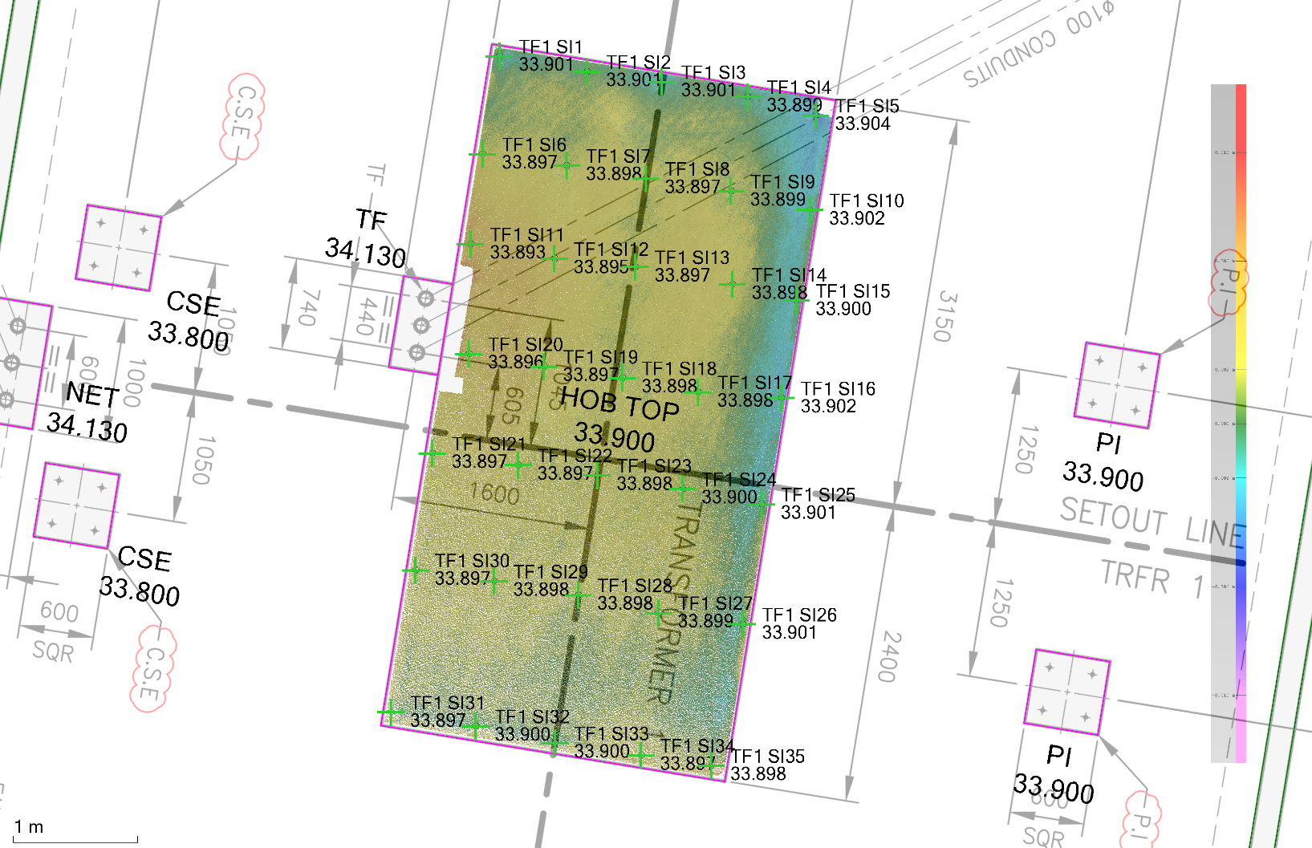

Scan Inspection Report
ID | Northing  (Meter) | Easting  (Meter) | Elevation  (Meter) | Deviation  (Meter)
TF1 SI1 | 5761771.057 | 598501.620 | 33.901 | -0.001
TF1 SI2 | 5761770.933 | 598502.322 | 33.901 | -0.001
TF1 SI3 | 5761770.850 | 598502.925 | 33.901 | -0.001
TF1 SI4 | 5761770.732 | 598503.615 | 33.899 | 0.001
TF1 SI5 | 5761770.581 | 598504.161 | 33.904 | -0.004
TF1 SI6 | 5761770.270 | 598501.484 | 33.897 | 0.003
TF1 SI7 | 5761770.180 | 598502.159 | 33.898 | 0.002
TF1 SI8 | 5761770.073 | 598502.796 | 33.897 | 0.003
TF1 SI9 | 5761769.972 | 598503.481 | 33.899 | 0.001
TF1 SI10 | 5761769.822 | 598504.114 | 33.902 | -0.002
TF1 SI11 | 5761769.547 | 598501.388 | 33.893 | 0.007
TF1 SI12 | 5761769.430 | 598502.062 | 33.895 | 0.005
TF1 SI13 | 5761769.364 | 598502.711 | 33.897 | 0.003
TF1 SI14 | 5761769.223 | 598503.491 | 33.898 | 0.002
TF1 SI15 | 5761769.095 | 598504.005 | 33.900 | 0.000
TF1 SI16 | 5761768.310 | 598503.886 | 33.902 | -0.002
TF1 SI17 | 5761768.357 | 598503.215 | 33.898 | 0.002
TF1 SI18 | 5761768.472 | 598502.609 | 33.898 | 0.002
TF1 SI19 | 5761768.563 | 598501.977 | 33.897 | 0.003
TF1 SI20 | 5761768.665 | 598501.373 | 33.896 | 0.004
TF1 SI21 | 5761767.865 | 598501.080 | 33.897 | 0.003
TF1 SI22 | 5761767.770 | 598501.770 | 33.897 | 0.003
TF1 SI23 | 5761767.688 | 598502.407 | 33.898 | 0.002
TF1 SI24 | 5761767.581 | 598503.090 | 33.900 | 0.000
TF1 SI25 | 5761767.455 | 598503.727 | 33.901 | -0.001
TF1 SI26 | 5761766.492 | 598503.574 | 33.901 | -0.001
TF1 SI27 | 5761766.582 | 598502.900 | 33.899 | 0.001
TF1 SI28 | 5761766.725 | 598502.253 | 33.898 | 0.002
TF1 SI29 | 5761766.838 | 598501.577 | 33.898 | 0.002
TF1 SI30 | 5761766.925 | 598500.945 | 33.897 | 0.003
TF1 SI31 | 5761765.785 | 598500.747 | 33.897 | 0.003
TF1 SI32 | 5761765.672 | 598501.426 | 33.900 | 0.000
TF1 SI33 | 5761765.535 | 598502.065 | 33.900 | 0.000
TF1 SI34 | 5761765.437 | 598502.758 | 33.897 | 0.003
TF1 SI35 | 5761765.355 | 598503.323 | 33.898 | 0.002

