Exercise 01A – Corridor with Soil Stripping Example and

Exercise 01B - Superelevation Review

Presenter
Alan Sharp – Trimble Inc.

Provided Files
- Alignment File (Alignment.vcl)
- Multiple Alignments File (Three Alignments.vcl)
- Original Ground Surface Model (Original Ground Model.TTM)
- Stripping Surface Model (OG Stripping Model.TTM)
- Planset Example (Example Plan and Profile.PDF)
- Typical Structural and Slope details (Example Typical, Structural and Slopes.PDF)

Exercise Summary
In this exercise we will explore the changes that have been made in v3.92 relating to managing soil or material layer stripping for corridor projects. In prior releases this was not at all easy to do. The process involves defining an unsuitable Material of Type Topsoil using the MSI manager and then defining the first strata layer in the Define Strata command as having that material below it.

Exercise Detail
- Start a new project using the project template
- Import the following data files
  - Alignment.vcl
  - Original Ground Model
  - OG Stripping Model
- Edit the MSI Library to create a Material called 00 – Stripping, set it to type Topsoil and set it to Unusable for Topsoil Replacement
- Define Strata for the corridor using the surfaces option
  - Set the Original Ground Model to the Original Ground Model
  - Set the material below Original Ground to be the 00 – Stripping Material
  - Set the next strata layer to be the OG Stripping Model
  - Set the material below the OG Stripping Model to be 02 – Site Soil Material
- Create a Corridor called Road
  - Select the HAL called HAL
  - Select the VAL called HAL
  - For Original Ground select the Original Ground Model Surface
  - For Native Material select 02 - Site Soil
  - For Fill Material select 02 - Site Soil
  - Select the Original Ground Model and the Strata (1) 02 – Site Soil as reference Surfaces
  - Select OK
- Insert a Corridor Template for Corridor Road – we will create that from scratch
  - Begin at Station 0
  - Select New Definition
  - Give the Template a name like T1
- Create the following instructions on the Right Hand Side of the Road Corridor
  - Offset / Slope, From the HAL, Offset =12’, Slope = -2%, EOP, Material Layer = Finish
  - Offset / Slope, From Previous node, Offset = 6’, Slope = -4%, SHLD, Material Layer = Finish
  - Side Slope, From Previous Node, Target Surface = Strata (1) 02 – Site Soil, Cut Slope = 2:1, Cut Ditch Width – 2’, Fill Slope = 3:1, Name = TIE – Strip
  - Mirror the instructions for the Left Side
Notes:
- You will see that the Stripping and Site Soil areas are now shown in different colors as shown below here
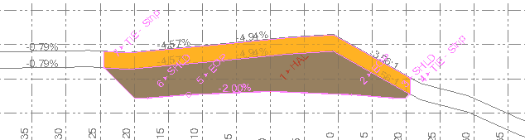
- You will also see that the Tie slopes will also tie vertically to the Original Ground Model. If you want the tie slopes to continue at the same slope to tie to the Original Ground Model, you can add a second Side slope instruction to Tie the Original ground at the same Cut and fill slopes – at the toe of the fill slope this will also generate you the lay back required for excavations of the stripping material. If you want the vertical elements in the Finished Surface model then you will have to add a side slope instruction with a vertical (Up or Down) tie and a 0 cut ditch width. You can use the words Up and Down as the Slope Ratio.
- In the Fill condition you will see the diagram shown as below. In this you can see that the stripping layer has the orange coloration which is quantified and also it is also filled with squares of the Site Soil color indicating that the stripped area is also computed as fill area in this case

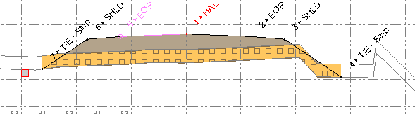
- Where you have both cut and fill conditions at the same station, you will see that as shown below. Note that in the top left corner of the section shows two areas for the Site Soil – one is the Cut Area and one is the Fill Area – note naming of the Native Cut and Fill materials dictates what is shown here and in output reports.
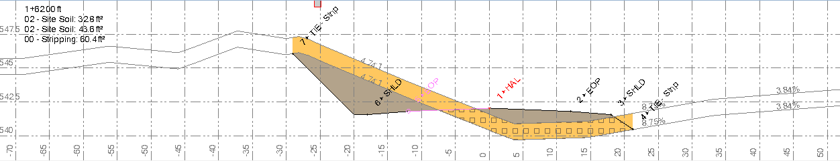

In the below example I have changed the definition of Fill Material in the Road Model to “Undefined” so that it now shows up in Blue color and is listed as Fill in the Area computations
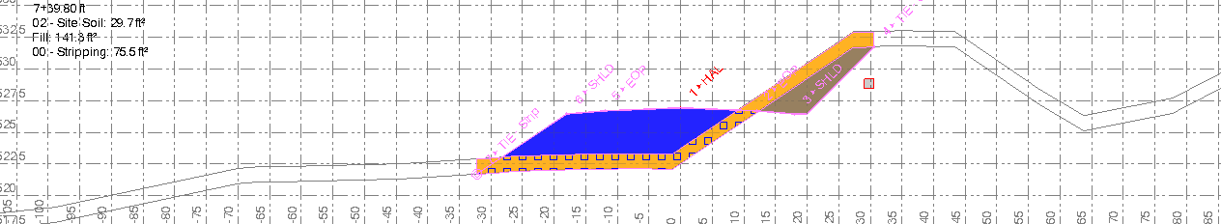

Advanced Modeling Problems
In the above examples, you will see that when you do a simple tie to the stripping layer and let the software tie to the Original Ground vertically, that in the Template editor, the tie to Original Ground shows up but if you review the corridor model in the 3D view you will see that the “Corridor Surface Model” does not show that element of the model.
If you then add the additional tie and use the Up or Down instruction for the Tie to create the Vertical element at either end of the section, you will get the vertical “UP” at the base of the Fill Slope and you will get the same Vertical “UP” at the end of the Cut slope.

Problem #1
If you want to add a continuation of the Cut Slope between the Stripping and Original Ground surfaces you will need to create a Cut Tie from SHLD to Stripping and then a second Cut Tie from Stripping to Original Ground. However in the Fill condition you will need to create the first Fill Tie from SHLD to Original Ground and the second Fill Tie from Original Ground to Stripping. Note that the first surface to tie to in the CUT condition is different to that of the FILL condition. This means that you will have to split the Cut and Fill instructions. That in turn means that you will need 4 instructions to achieve this.

Problem #2
For Problem #1 the simplest approach is to do the Right Side first and then define the Left side second. In both cases it is best if you create the instructions by linking the instruction to Previous Node rather than a specified node – Why?
Because as the Geometry changes along the route, the SHLD will sometimes be below Stripping and sometimes between Stripping and Original Ground or above Original Ground. As a result you could have the following sequences of nodes
Condition 1 - When SHLD is below stripping
- SHLD – TIE Strip – TIE OG
Condition 2 - When SHLD is above stripping but below Original Ground
- SHLD – TIE OG (Note the TIE Strip node will not get created here)
Condition 3 - When SHLD is above Original Ground
- SHLD – TIE OG – TIE Strip
Because the sequence of nodes will vary based on where the SHLD node is, we should use the “Previous Node” for each of these instructions, so that irrespective of which node was / was not created we can create the appropriate sequence.
In this case when we are in Condition 2 above, the Instruction SHLD to TIE Strip will fail because a Cut Slope will not be found between SHLD and TIE Strip, and so the previous node in this case will be still SHLD. The connection between SHLD and TIE OG can then be created.
In this case when we are in Condition 1 above, the instruction SHLD to TIE Strip will pass and get created because a Cut slope from SHLD to the stripping layer can be found. For the next instruction the previous node would then be the TIE Strip node and not the SHLD node as in Condition 2.

Problem #3
Problem #3 will then appear because we now have 4 instructions which all use the “Previous Node”.
No matter which order you put the 4 instructions (2 for Fill and 2 for Cut) when using the “Previous Node” method you will create additional cross section elements that you don’t need / want
Cut Conditions First
When you create the Cut Conditions first, the second tie (to Original Ground) creates a node that is above the Stripping Layer, and therefore when the Fill instructions are processed they will create an extra Tie from the Cut Tie that ends at the Original Ground back down to the Stripping Layer because we are using the Previous Node method.
Fill Conditions First
Because the Fill slope first creates a node at the Original Ground and then at the Stripping Layer, this node is below the Original Ground Layer, and therefore when the Cut Instructions are processed they will create an extra Tie from the Fill Tie that ends at the Stripping Layer back up to the Original Ground Layer because we are using the previous Node method.
In order to solve Problem #3 you will need to
- Use a Condition Statement that checks whether the SHLD node is in Cut and if Yes then process the Cut Instructions, followed by an End IF statement
- Use a Condition Statement that checks whether the SHLD node is in FILL and if Yes then process the FILL instructions, followed by an End IF statement
- There will be two Conditions on the Right Side and two on the Left side of the Template to solve this issue.
Below is a screen grab of the Instruction List for the Right Side of the Template
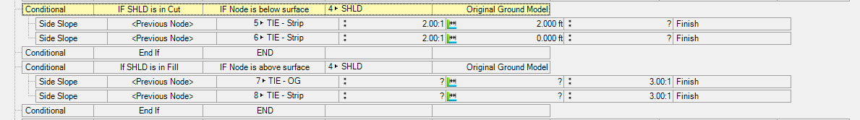

Problem #4
Now that we have all of the Ties working let’s take a look at adding Superelevation to the alignment.
Superelevation is applied to a road pavement surface as it approaches and departs from curved sections. Superelevation helps the driver to stay on the road in a curve as it mitigates the effects of centripetal forces caused by latera acceleration as you enter a curve. Superelevation minimizes the steering wheel shift that the driver needs to apply as they enter the curve.
The key elements of superelevation are the following
- Normal Cross Slope - of the road e.g. -2% (on straight sections of the road the cross slope is designed to help the road drain in wet conditions)
- Max Superelevation - to be achieved while in the curve. The max super is directly related to the degree of curvature of the curve and the design driving speed of the vehicle. The tighter the radius or the greater the speed the greater the maximum super required.
- Vertical Curve Length - In some cases rather than a linear transition from No Super to Super, the cross slopes at the start and end of the superelevation can be controlled by parabolic vertical curves that ease the transition from -2% to superelevation so that they don’t abruptly start and end. In this case the length of the vertical curve is defined.
- Compound Maximum - When two arc curves of the same or different radii and the same direction (left or right) are sequential on an alignment or are separated by a short straight section, the two curves will have different max superelevations because the radii are different. The Compound Maximum is the maximum distance (station difference) between the end of one super and the start of the next super that below which the two supers will be considered to be joined into one continuous superelevation. This stops the downward transition from the first curve and then a restart of the upward transition for the next curve in quick succession to improve the drive conditions for the vehicle operator. Increasing this value has the effect of joining more superelevations together.
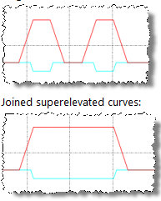
- Reverse Maximum – This is similar to the Compound Maximum value but it relates to where successive curves are of opposite directions i.e. a Left Hand Curve then a Right Hand Curve. The value entered here is the Maximum Distance before the two curves are considered separate. When below the entered value, the Transition from Full Super on the first curve to full super on the second curve will be modified to be at a constant rate and applied linearly between them.
- Runoff % in Curve – in a superelevation there are three stages for the approach and departure to a curve. If we take a normal road with -2% cross slope both sides of the centerline. If we are entering a Right Hand curve, the Left Side of the road will superelevate in the upward direction and the Right Side in the downward direction. The three stages are as follows
  - On the outside of the curve, the pavement goes from -2% to 0%. This is called tangent runout. This always happens in the straight section of the road. (remember Runout = outside the curve)
  - On the outside of the curve, the pavement goes from 0% to +2%.
  - On the outside of the curve, the pavement goes from +2% to the Maximum superelevation e.g. +5%. At the same time the inside of the curve, the pavement goes from the -2% to the opposite of the maximum superelevation i.e. -5%. Steps (b) and (c) are called Superelevation Runoff. Runoff is defined as a length and how much of the runoff as a % of the total runoff is in the curve e.g. 100’ runoff and 25% in the curve. The remaining 75% of runoff would then be in the straight section of the alignment.
Note: when running Spiral – Arc – Spiral sections for a curve the Runoff is often taken up entirely in the spiral sections of the curve. This is entered as 0% Runoff in the curve (the arc section).
The following diagram shows the three stages of superelevation
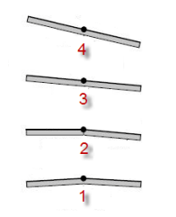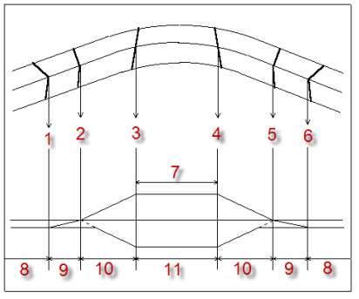
- Runout length – The runout length is typically computed using the runoff rate (this is the rate of change of cross slope computed as % change per foot i.e. if you had a change of 4% over 100’ then you would have a rate of 4% / 100’. This “rate slope” is continued to take the last 2% of change of cross slope – and would therefore be a further 50’.
- Use runoff rate for runout – select this check box if you want to compute the runout length using the same rate as the runoff rate. Keeping these the same means that as a driver you will not suddenly feel a faster or slower rate of change of cross slope as you cross the runout / runoff divider.
Superelevation has already been entered on the Horizontal Alignment that you imported. Let’s take a look at how superelevation is defined
The critical factors on applying Superelevation in a Template are that the instruction needs to appear directly after the pavement elements have been created and before any other elements are added. This will mean if you have “Mirrored” instructions that you may need to move the Left side Pavement instruction up the list of instructions so it is directly after the Right side pavement instruction. For example you should have this sequence in your instruction list
- Offset / Slope, From Node HAL, +12’, -2%, EOP
- Offset / Slope, From Node HAL, -12’, -2%, EOP
- Superelevation
If you are applying Rollover parameters to your Shoulder elements, they will be taken into account as they are computed provided that the SHLD elements appear after the Superelevation instruction. Rollover stops the slope change between the Pavement and the Shoulder getting too large i.e. in normal cross slope the pavement has -2% and the Shoulder has -4% cross slope, this is a difference in slope of 2%. When you super the pavement to say +6% on the up side, if the shoulder does not change cross slope you will have a slope difference of +6% to -4% that is a rollover of 10% which is too extreme for a car pulling over to the shoulder. The Rollover controls how these slopes change as super is applied.
Secondly, you need to be clear whether the Pivot point is the center line or one of the nodes of the corridor (typically either the Inside (down slope side node) / Outside (Up slope side node).
If the supers are defined with the pivot point at the Inside or Outside (typically done to hold the elevation on the down slope side for drainage purposes) then the centerline node will rise above or below the centerline defined elevation as it enters superelevation above the normal cross slope (-2%/+2%). Note this scenario cannot be modeled with Slope Tables, only with superelevation instructions.
If the supers are defined with the pivot point at the centerline, then the centerline node will follow the vertical profile of the alignment, and the pavement edges will rotate about that point. This scenario can be managed using Slope Tables.
The following diagram shows the difference graphically
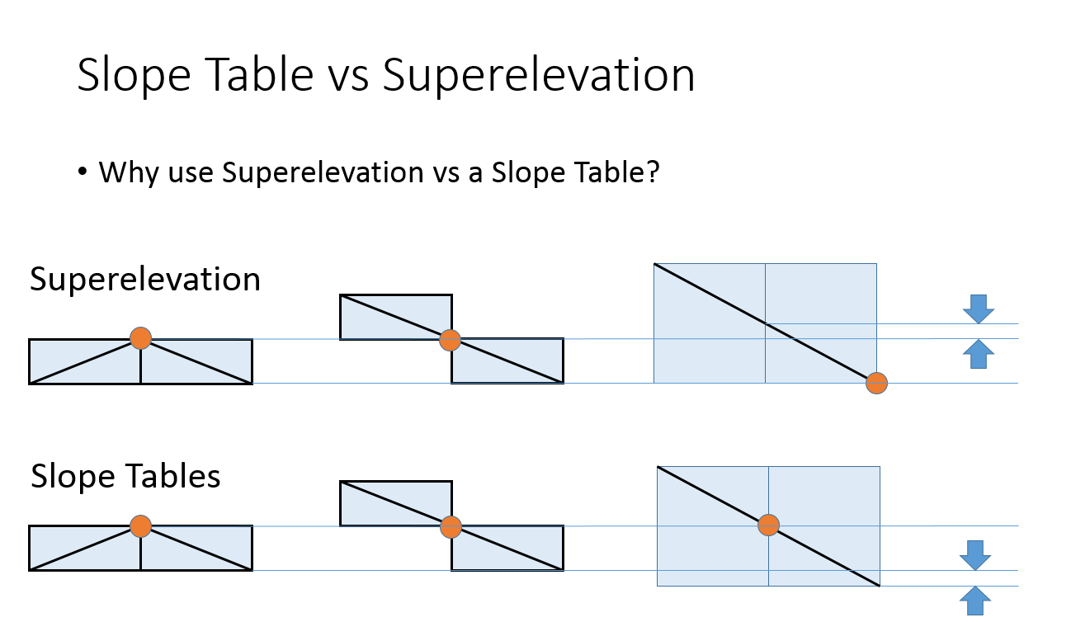
Let’s take a look at a few alignment examples and how these superelevation settings apply

Exercise Steps
- Start a new project using the training template
- Import the file “Three Alignments.vcl”
- Let’s first take a look at the Blue Alignment called HAL 2
- In this alignment you can see the curve sequence includes the following
  - Straight (L = 200)
  - Right Hand Arc (R = 300, L = 150)
  - Straight (L = 125)
  - Right Hand Arc (R = 200, L = 200)
  - Straight (L = 100)
  - Left Hand Arc (R = 200, L = 200)
  - Straight (L = 200)
  - Left Hand Arc (R = 200, L = 200)
  - Straight (L =200)
- Let’s take a look at the superelevation information for this alignment
  - Select the alignment and right click to Edit the alignment
  - Select the Superelevation tab of the alignment editor
  - From the superelevation editor, click the button labeled Superelevation – this will open the Superelevation Diagram window. Drag the diagram window so that you have the Diagram in the top pane and the Editor in the bottom pane.
- Immediately here you will see two new features of the Superelevation diagram
  - The rates of runout and runoff are now displayed on the superelevation diagram lines
  - Along the zero% cross slope line you will see a series of blue dots – these are the PC and PT points of the alignment – so you can now clearly see where the alignment elements start and end.
- The Blue line is the Left side of pavement, the red line is the right side of the pavement
- At this point you can see that each of the superelevations are isolated from each other for each curve – there are no compounding or reverse compounding superelevations at this time.
- In the superelevation editor
  - You will see the first curve at Station 2+00 selected
  - You can see that the superelevation parameters have been set. Ensure that the “Advanced” check box is ticked so that you can see the advanced parameters.
  - Note the Join to previous functions for Compound Maximum and Reverse Maximum have no value on the first curve as there is no previous curve to work with.
  - For the first curve, change the Departure Runoff length to 100’ from its value of 50’. Note what happens. Because the runoff length now pushes to an overlap with the next curve, the two superelevations are joined together into one continuous superelevation. If either the Departure of the first curve or the approach to the second curve changes in this way, you will see the same effect. Undo what you just did, switch to the second curve and change the approach runoff length to 100’ from its value of 50’. You will see a similar result. Undo once more. This is auto-compounding – when two supers cross each other they are automatically joined into a continuous super.
  - In the second curve, change the compound maximum value to 50’ from its value of 0’. You will again see a similar result to that shown in the previous example. The difference here is that we are not changing the supers themselves, we are changing the allowable gap between them to be as high as 50’ below which the two supers are compounded.
  - Between the second and third curves there is a reverse in direction. Currently you can see that each super is not affecting the other. Select the third curve. Now set the reverse maximum to 50’. You will see that a smooth linear transition between the Right Hand and Left Hand curves is created. Undo what you just did.
  - Let’s take a look at the Vertical Curve Length. Select the first curve. Enter a vertical Curve Length of 20’. See how the superelevation diagram now has a curve on both the blue and red lines of the diagram for both the approach and departure. Undo what you just did.
  - Let’s take a look at what changing the Runoff % in Curve or Runoff length does to the diagram. Select the first curve. For the Approach data change the Runoff % in Curve value to 45% from its value of 20%. What happens? Correct. The start and end of the transition move up station because now more of the runoff is in the curve than before. Now change the value to 10%. It will now move the other way. Reset the value to 25%. Repeat the process for the Departure data. Change the departure value to 25% from its current value of 50%. Reducing the departure number moves the transition up station. Increasing the departure % moves the transition down station.
  - Now do the same thing for the approach and departure Runoff Lengths. Change the Approach Runoff length to 100’. Note increasing the runoff length reduces the slope of the transition segment because now the rate of change of slope will be slower because it is taking place over a longer distance. The start and end points move because by increasing the length from 80’ to 100’ the 25% in the curve value goes from 20’ to 25’ and the part that is outside the curve goes from 60’ to 75’.
  - Let’s also check out how the use of Use runoff rate for runout checkbox affects the calculations. For the first curve, for the approach uncheck the Use runoff rate for runout checkbox. You will see that the Runout length value is now set to 0 from its prior value. You can now enter a value for runout length. Enter a value of 10 for example. You will see that the slope of runout is now greater than that of runoff. This is pretty uncommon.

This is a good example to work with to learn how the superelevation is being computed and used. As you change the values you will also see the rates of runout and runoff changing.

Let’s also take a look at the Green Alignment called HAL 3.

- This alignment has the following geometry elements
- Straight (L = 150)
- Right Hand Spiral In (L = 100, End Radius = 300)
- Right Hand Arc (L = 250, R = 300)
- Right Hand Spiral Out (L = 100, Start Radius = 300)
- Straight (L = 100)
- Left Hand Arc (L = 200, R = 300)
- Straight (L = 100)
- Select the superelevation tab
- Click the Superelevation button to create a superelevation diagram. Move the superelevation diagram to the upper window.
- For higher speed roads where spirals are typically used to assist drivers to transition from a straight section into an arc curve section (A spiral or spiral element transitions the alignment geometry from straight (infinite radius) or arc radius 1 to arc radius 2 or vice versa. In many cases the spiral segment is used to take up all of the runoff value so that there is no runoff in the curve. Even though a spiral is in reality a curve, when superelevation refers to a curve it is always referring to an arc element.
- In this example you will see that we have set the approach and departure Runoff % in the curve to 0% and set the Runoff Length to 100’. This you can see aligns with the blue alignment geometry points marked at the 0% line. You can of course change the values as for any geometry, however it is worthy of some time to see how spiral – arc spiral elements are managed.
As a contractor it is uncommon for you to need to design geometry and superelevation, this information should all be provided on the plans and your job is to simply use the tools provided to key in the geometry from the plans.
To complete this session, let’s take a look at a set of plans from Alaska DOT to see how they provide the data required for data entry here.

Exercise Steps
- Outside of Business Center – HCE open up the PDF file called Example Typical, Structural and Slopes.PDF. Turn to page 5 of this document. Review the details of superelevation provided here. This information will help you to read the plans.
- What is interesting in this drawing when compared to what we have covered so far? That’s right in this diagram they show the Total runoff and then they show the runoff % as being the part prior to the PC/PT point of the curve. This is the reverse of how it is usually defined. The use of the runout is consistent with what we have covered so far.
- Now open the other PDF file called Example Plan and Profile.PDF, and review the first few sheets of the Plan and Profile drawings for the project and see if you can find and extract on paper the important information for the first few curves of the project.
- Let’s review what you found out

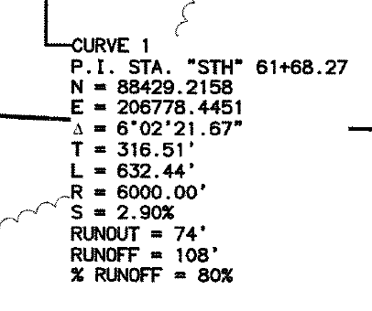

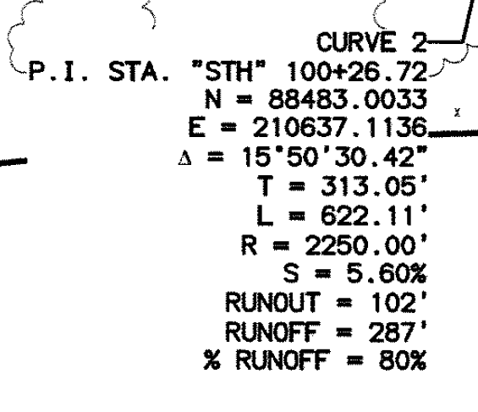
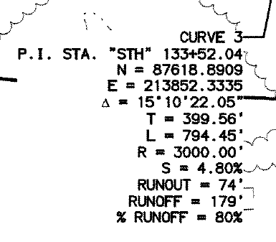
The important values are as follows
Curve 1
- Radius = 6000
- Normal Cross Slope = -2%
- Max Super = 2.9%
- Runoff Length = 108’
- Runout Length = 74’
- % Runoff = 80% (Note that this is outside the curve so we want 20% in the curve)
- Rate of Runoff = 2.68% / 100’
- Rate of Runout = 2.702% / 100’
Curve 2
- Radius = 2250
- Normal Cross Slope = -2%
- Max Super = 5.6%
- Runoff Length = 287’
- Runout Length = 102’
- % Runoff = 80% (Note that this is outside the curve so we want 20% in the curve)
- Rate of Runoff = 1.95% / 100’
- Rate of Runout = 1.96% / 100’
Curve 3
- Radius = 3000
- Normal Cross Slope = -2%
- Max Super = 4.8%
- Runoff Length = 179’
- Runout Length = 74’’
- % Runoff = 80% (Note that this is outside the curve so we want 20% in the curve)
- Rate of Runoff = 2.68% / 100’
- Rate of Runout = 2.70% / 100’

Comments
- See how the smallest radius has the largest max superelevation
- See how the Runoff Length and Runout Length values are different for every curve
- See how the rates of runout and runoff are almost the same yet they are different for every curve. Note: While the difference between runoff and runout rate is small and likely negligible in terms of construction accuracy and tolerance, it is likely a plans rounding error – BC-HCE will compute the true values based on the runoff data entered. If you want to match the plans you can uncheck the use runoff rate for runout checkbox and simply enter the values from the plans, or you can assume / verify that it is a plans rounding issue and let BC-HCE compute the true values.

